

|  |
| --- |
| A comprehensive guide on the use of Let’s Talk in practice |

|  |  |
| --- | --- |
| TRAFFORD  COUNCIL | Let’s talk: Adult Social Care Operational Guidance |

Contents (1)

**Part 1 Let’s Talk: A Strengths Based Approach to Adult Social Care**

Introduction (1.1) 2

Trafford Council’s Approach (1.9) 3

Let’s Talk Assessment Conversation Overview (1.14) 3

The Golden Rules (1.17) 4

**Part 2 Let’s Talk: Ensuring your work is Legally Compliant**6

Introduction (2.1) 7

Status of this Guidance Note (2.5) 7

Needs and Carers Assessment (2.8) 7

Proportionate Assessments – General Requirements (2.11) 7

(Assessment) Conversations Wellbeing and Prevention (2.18) 8

(Assessment) Let’s Talk 1 (2.25) 9

Decision Making Folllowing Let’s Talk 1 (2.29) 10

Let’s Talk 2 and Crisis (2.37) 11

(Assessment) Let’s Talk 2 (2.38) 11

Decision Making Following Let’s Talk 2 (2.45) 12

(Assessment) Let’s Talk 3 (2.52) 13

Rights to make representation about Trafford Council decision making under Let’s Talk (2.58) 15

**Part 3 Let’s Talk: Quality Standards** 17

Introduction (3.1) 18

**Standard 1**: Conversations/Assessments will be proportionate to the presenting situation (3.8) 19

Contents (2)

**Standard 2:** Conversations/Assessments will focus on an understanding of

the wellbeing of the individual (3.9) 19

**Standard 3:** Recording will state how the need for care and support has been prevented, delayed or reduced as a result of the conversation or through

planned interventions (3.10) 20

**Standard 4:** Recording will state how the duty to protect adults at risk of abuse

or neglect will be responded to (3.11) 20

**Part 4 Let’s Talk: Ensuring your work with carers is Legally Complaint** 21

Introduction (4.1) 22

Status of this Guidance Note (4.6) 22

Needs Assessments and Carers (4.9) 22

Proportionate Assessments – General Requirments (4.11) 22

(Assessment) Conversations Wellbeing and Prevention (4.20) 23

(Assessment) Let’s Talk 1 (4.26) 24

Decision Making Folllowing Let’s Talk 1 (4.30) 24

Let’s Talk 2 and Crisis (4.35) 25

(Assessment) Let’s Talk 2 (4.36) 25

Decision Making Following Let’s Talk 2 (4.42) 26

(Assessment) Let’s Talk 3 (4.47) 27

Rights to make representation about Trafford Council decision making

under Let’s Talk (4.52) 28

**Part 5 Lets Talk: Case File Recording** 29

Introduction (5.1) 30

Accountability of Practitioners and Managers (5.6) 30

Recording on Case Notes and Assessment Documents (5.8) 30

Recording Facts and Opinions/Professional Judgments (5.13) 31

**Part 6 Let’s Talk: Strengths Based Audits** 32

Introduction (6.1) 33

Audit Schedule (6.4) 33

Care Act 2014 Underpinning Principles (6.11) 34

Audit Judgment on compliance with Care Act 2014 Principles (6.14) 35

**Part 7 Let’s Talk: Assessment Conversations Liquid Logic Forms**

**and How to Use Them**  36

Introduction (7.1) 37

Overview of diagram for Let’s Talk Process (7.6) 37

New Contact Received

New Case Opened or Contact Closed

Assessment Let’s Talk Forms 1 & 2

Assessment Let’s Talk Form 3 Funded Support

Detailed Liquid Logic Process

**Appendicies**

Appendix A: Life Stories

Appendix B: Strengths Based Audit Tool



Part 1

Let’s Talk

A Strengths Based Approach to Adult Social Care

* 1. **Introduction**
  2. Strengths-based practice is a collaborative process between the individual and those supporting them, which encourages working together to determine an outcome that draws on the person’s strengths and assets.
  3. As such, it concerns itself principally with the quality of the relationship that develops between those providing support and those being supported, as well as the elements that the person seeking support brings to the process. Working in a collaborative way promotes the opportunity for individuals to be co-producers of services and support rather than solely consumers of those services.
  4. The term ‘strength’ refers to the different elements that help or enable the individual to deal with challenges in life in general and in meeting their needs and achieving their desired outcomes in particular. These elements include:
* Their personal resources, abilities, skills, knowledge, potential, etc.
* Their social network and its resources, abilities, skills, etc.
* Community resources, also known as ‘social capital’ and/or ‘universal resource’

***“Social Care Institute for Excellence – March 2015”***

* 1. Strengths based approaches are at the heart of the Care Act 2014 which was introduced on 1st April 2015. The Care Act 2014 has been described as the most significant reform of legislation covering care and support (for adults and their carers) in more than 60 years, putting people and their carers in control of their care and support.
  2. In addition to replacing outdated legislation that was not fully compatible with the Human Rights Act 1998 and Mental Capacity Act 2005, the Care Act 2014 replaced the Care Management approach that was introduced under the NHS and Community Care Act 1990. This approach was built around a deficit model of Adult Social Care assessment and support planning, which did little to support and build on the strengths of the individual, or their available networks; therefore increasing people’s dependence on long term funded support with no clear link to a good quality life.
  3. Section 1 of the Care Act 2014 places an overriding duty on Local Authorities and their partners to ensure the promotion of people’s wellbeing and independence is central to all the functions undertaken. This is best achieved through a strengths-based approach to the assessment conversation, which enables people to be supported to understand their needs, realise what they can achieve independently, and how to best use their skills and networks (including community assets), to achieve their outcomes.
  4. **Trafford Council’s Approach**
  5. Let’s Talk is Trafford Council’s approach to delivering strengths based Adult Social Care and follows a successful roll out of the “3 Conversations Model”, developed by Partners4Change. This operational guidance has been developed to ensure practitioners working in Adult Social Care understand how to deliver strengths based social care under the framework of Let’s Talk, and in accordance with the statutory duties set out in the Care Act 2014 and associated care and support statutory guidance.
  6. This approach has been developed with front line practitioners and supports staff to spend more time with people in a way that recognises the value of building relationships in order to support people to live the lives they choose. This is achieved through developing a deeper understanding of each person’s unique view of the world and views about what makes a good quality life, which replaces a formulaic approach to deficit model assessment and support planning.
  7. The approach has enabled Trafford Council to reduce the administration burden on front line staff through the redesign of systems, processes and associated documentation, which provides the space to build valuable relationships.
  8. However, staff must ensure they understand their individual accountability when implementing “Let’s Talk” as all practitioners employed by Trafford Council are responsible for ensuring good quality records are maintained in order to support defensible decision making.
  9. Practitioners are also reminded of the need to ensure they understand their accountabilities as set out in the Case File Recording Policy.
  10. **Let’s Talk Assessment Conversation Overview**
  11. Let’s Talk is underpinned by three distinct assessment conversations which will be determined by the presenting needs and circumstances of the adult with care and support needs and/or their carer. The following is an overview of the purpose of each assessment conversation and staff must refer to the Legal Guidance Note set out in Part 2 & Part 3 of this operational guidance to ensure they understand how to implement each assessment conversation in practice for adults with care and support needs and their carers.
* **Assessment Let’s Talk 1**…is designed to explore people’s needs and connect them to personal, family and community sources of support that may be available
* **Assessment Let’s Talk 2**… is designed to respond to crisis situations. The focus is on identifying the immediate actions that supports people to maintain their safety and prevent their situation and wellbeing deteriorating to the point where resource intensive solutions are required
* **Assessment Let’s Talk 3**… focuses on long-term outcomes and planning, built around what a good life looks like to the person and how these needs and outcomes will be met through ongoing social care funding.
  1. Let’s Talk provides practitioners with more freedom to think and act differently within a set of guiding principles that are often referred to as the ***‘golden rules’*** in the sense that they provide challenge to existing Adult Social Care approaches and assurance around consistency of application for the new way of working.
  2. **The Golden Rules**
  3. Every assessment conversation must start with the assets and strengths of people, families and their wider community.
  4. All assessment of Let’s Talks are proportionate assessments and are in line with S9 (assessing needs of adults) and S10 (assessing needs of carers) of the Care Act 2014. Therefore practitioners must ensure the needs and outcomes of the individual cannot be met through assessment Let’s Talk 1 & 2, before progressing to an assessment Let’s Talk 3.
  5. Practitioners should maintain close working relationships during all assessment Let’s Talk 2’s and empower people to develop the required skills to manage independently during periods of crisis, as there is nothing more important than supporting someone to regain control of their own life.
  6. Long term plans must not be made when a person is at a point crisis as this will not provide a proportionate or least restrictive approach to supporting an individual’s needs and outcomes.
  7. Practitioners must ensure they listen hard to individuals and their carers and do not bring their own preconceived opinions to the conversation, as people and their carer’s are the experts on their own lives.
  8. Practitioners must get to know the neighborhoods / communities which people live in and the community assets that people can be connected to if they are to work in an asset and place based way.
  9. No decisions about people should be made without people and all solutions must be co-produced with each person to ensure this reflects their unique situation and views about a good quality life. This will need to consider the persons representative when the individual does not have the mental capacity to make an issue specific decision.
  10. Assessment conversations must focus on the things that will support people to live a good life and where funded support is required the co-produced solutions must meet this outcome.
  11. You must collect information that helps inform practice and decision making so we understand what’s happening and the actions that lead to good quality outcomes for people.



Part 2:

Let’s Talk

Ensuring your work is Legally Compliant

2.1 **Introduction**

2.2 Let’s Talk is an approach to responding to individuals who need support to get on with their lives. It is built on a commitment to focus on the assets and strengths of people, their informal networks and wider community assets.

2.3 It requires staff to have solution focused conversations with individuals to work out collaboratively how to support people to live their chosen lives.

2.4 This approach to Adult Social Care is underpinned by defendable and accountable decision making, which will support Trafford Council to provide a robust evidence base for fulfilling its statutory duties as set out in the [Care Act 2014](http://www.legislation.gov.uk/ukpga/2014/23/contents/enacted).

2.5 **Status of this guidance note**

2.6 This guidance note is intended as a professional guidance note only to help staff understand how they should evidence appropriate decision making when using Let’s Talk on behalf of Trafford Council.

2.7 This guidance note does not replace primary legislation (referred to above) or the [Care and support statutory guidance](https://www.gov.uk/government/publications/care-act-statutory-guidance/care-and-support-statutory-guidance) (Updated 9th July 2018) and staff must ensure they refer to these, or seek additional advice to inform lawful decision making if they are unclear on how to discharge statutory duties on behalf of Trafford Council.

2.8 **Needs and carers assessment**

2.9 When considering the needs of the adult with care and support needs, Practitioners will also need to have due regard to the needs of carers who are entitled to an assessment of their needs and outcomes in their own right. This is of critical importance when the adult they are caring for refuses an assessment or support to meet their needs and outcomes and there is an impact on the wellbeing of the carer.

2.11 Trafford Council’s statutory duties in respect of assessing the needs of individuals and carers are set out below.

* Section 1, 2 , 9 – 13, 21 of the Care Act 2014;
* Care and Support (Assessment) Regulations 2014;
* Care and Support (Eligibility Criteria) Regulations 2014;
* Care and Support (Preventing Needs for care and support) Regulations 2014
* Care and support statutory guidance , Chapters 1, 2 and 6

2.11 **Proportionate assessment – general requirements**

* (3) - (1) A local authority must carry out an assessment in a manner which (a) is appropriate and proportionate to the needs and circumstances of the individual to whom it relates

2.11 Let’s Talk will ensure that assessments carried out under the Care Act 2014, are both appropriate and proportionate. Whilst these are the guiding principles for all assessments, this is not at the expense of ensuring the statutory requirements of an assessment are met.

2.12 In carrying out appropriate and proportionate assessment conversation the social care officer will take into account the –

* Individual’s preferences;
* Individual’s assets, those of their informal support networks and wider community;
* Outcomes the individual is seeking to achieve, the severity and overall extent of the individual’s needs;

2.13 It is the responsibility of the individual worker (in consultation with their line manager if required) to determine the proportionality and appropriateness of the type of conversation they are using. This will be based on the relevant circumstances of the individual; the presenting needs and level of risk.

2.14 Social care officers, in performing assessment conversations, must also take account of what has happened over a period of time, and what they think is sufficient to establish an accurate picture of the individual’s needs and outcomes.

2.15 Let’s Talk is not a formulaic linear approach. If Let’s Talk 2 is the most appropriate and proportionate response then workers must use this immediately, as a means of helping avert an imminent crisis.

2.16 All conversations focus on needs, outcomes and what the person wants to achieve, seeking to promote the individuals wellbeing as the underpinning approach. Social care officers must use their discretion and professional judgement (in consultation with their line manager, or peer support if required.

2.17 When considering how to perform an assessment conversation. The Care Act statutory guidance makes clear a face to face assessment may not be necessary in every case, but officers are reminded that Trafford Council must ensure it can evidence how it has discharged its statutory duties in all situations.

2.18 **(Assessment) Conversations Well-being and Prevention**

2.19 Let’s Talk promotes a proactive, dynamic and committed approach to ‘reduce, prevent, and, or delay’ the need for care and support and concentrate on promoting the wellbeing of the individuals concerned.

2.20 It is focused on having conversations based on what ‘people want to tell us’ and ensuring we capture enough information to do a lawful assessment conversation.

2.21 Let’s Talk 1 and 2 are focused on preventing or delaying the need, wherever possible, for dependence on long term formal care. This replaces a deficit model approach to social care and replaces this with a commitment to delivering a strengths based approach. Section 2 Care Act 2014:

* Chapters 1 and 2, Care and Support Guidance 2014 – describe duties to promote wellbeing and reduce, prevent or delay needs arising;
* Para 1.2 and 1.5 – describe duty to promote wellbeing;
* Para 2.3 – commitment to prevention.

2.22 Social care officers are required to ensure the assessment conversation covers the following:

* Impact of the needs on all aspects of wellbeing;
* Outcomes the person wants to achieve;
* Whether and to what extent the provision of care and support would contribute to those outcomes.

2.23 Additionally, when working with carers the following will need to be considered when undertaking assessment conversations:

* Whether the carer is able and willing to provide care;
* Whether the carer works or is participating in education, training or recreation or wishes to do so;
* The Wellbeing of the carer, their needs and outcomes in accordance with the Primary Legislation and Statutory Guidance Set out above.

2.24 Carer’s assessment conversations will not be covered in this guidance as the function is undertaken by the Carers Centre on behalf of Trafford Council. Separate guidance will be produced to set out how Trafford Council will evidence how it has met its statutory duties in respect of carers.

2.25 **(Assessment) Let’s Talk 1**

2.26 Is a proportionate assessment conversation and is concerned with connecting people to things that make their life work without the need to solely rely on state funded support (e.g. connection to community groups, other people in similar circumstances, a grab rail, etc. – whoever pays for it).

2.27 Staff are reminded that they are empowered to have more than one Let’s Talk 1 to support the prevention of care and support needs.

2.28 When using Let’s Talk 1 staff are -

* Helping individuals to build on their own strengths and those of their informal networks, whilst also helping them connect to their own communities so the focus is not on the individual’s eligibility for long term funded social care support;
* Demonstrating how they are working to prevent, reduce, or delay needs for care and support;
* Not acting as gatekeeper for accessing services, as it is concerned with understanding what will enable the person to live a ‘good life’ and facilitating that through community connections.
* Interested in finding out ‘what the person needs and what they want to do (outcomes) to get on with their life’

2.29 **Decision making following Let’s Talk 1**

2.30 When discharging its statutory duties Trafford Council must ensure it can demonstrate it has provided an equitable response that is based on the individual’s presenting needs and relevant circumstances.

2.31 Therefore when undertaking a proportionate (assessment, or reassessment) conversation in respect of an individual’s needs and circumstances, social care officers must ensure that they undertake a strengths based Let’s Talk 1.

2.32 This will enable Trafford Council to demonstrate the actions it has taken to build upon individual’s strengths, evidence the support that is available from the person’s informal networks, and the community resources we have been able to connect the individual to.

2.33 To ensure compliance with the relevant Legislation and annual statutory returns (Short and Long Term - SALT) in respect of assessments and reassessments, social care officers discharging this function on behalf of Trafford Council will need to ensure they document the following on the Let’s Talk 1 Proforma (in Liquid Logic).

* The presenting needs of the individual (e.g. the issue(s) that the individual is seeking support with), this may include needs that require urgent action from Trafford Council as it relates to self-neglect, hoarding, failure to gain access and there are concerns for the persons welfare, or the unwise decision making of the individual places them as significant harm and potential risk of death;
* The issues that individuals want to discuss and other information known to the Local Authority (e.g. the relevant circumstances);
* The individual’s description of their own wellbeing (e.g. the outcomes the person is seeking to achieve / how they want to live their life, which must include consideration for the individuals safety);
* The actions that have been agreed with the individual and undertaken in response to the presenting needs and relevant circumstances (this must include the individuals strengths, their informal networks and community based responses that we have reconnected the individual to);
* The outcome of the conversation and conclusion of agreed actions - If there are no ongoing presenting needs Trafford Council has effectively discharged its statutory duties and has no ongoing role with the individual concerned. If there remains a presentation of need the social care officer will need to consider what actions are required (including further conversations).

2.34 Where individuals are in receipt of a social care funded package of support and conversation 1 evidences that the individuals needs and outcomes can be met in a different way / changes are made to the level of social care funding that is provided. Social care officers will be required to evidence the following on the Let’s Talk 1 Proforma –

* Adults with Mental Capacity for the issue and time specific decision - changes have been made in consultation with the individual who has the mental capacity to make decisions in respect of how their care and support needs should be met and the outcomes they are seeking;
* Adults without Mental Capacity for the issue and time specific decision - Changes have been made following a best interest decision that evidences all of the relevant circumstances that have been considered as part of the decision making process. NB staff are reminded of the duty to provide an IMCA or Care Act Advocate under specific circumstances and should refer back to the statutory guidance for further information if in doubt;
  1. **Let’s Talk 2 and Crisis**
* Secs 3,6,7,22, 23, 74 and schedule 3 of the Care Act 2014 deal with a) duties to cooperate and b) integration to promote wellbeing;
* Guidance in Chapter 15, Care and Support Guidance 2014
* Para 15.4, duty to cooperate to promote wellbeing, prevent or delay needs arising, and to improve the quality of care and support;
* Covers health, housing, welfare and employment.

2.38 **(Assessment) Let’s Talk 2**

2.39 When an individual’s circumstances mean they have reached a point of crisis and an immediate response is required, staff must undertake Let’s Talk 2.

2.40 This will ensure social care officers understand what is causing the crisis, what needs to change immediately, and how they will work with the individual to enable those changes to happen wherever possible.

2.41 This conversation assessment is concerned with putting a plan together shaped by the key things that need to immediately change to help create stability in an individual’s life.

2.42 If these things don’t happen it is recognized the individual will experience an immediate decrease in their mental and physical wellbeing, this includes actions required (under safeguarding adults processes) to help prevent abuse or neglect, and the loss of life.

2.43 When using Let’s Talk 2 staff will ensure -

* The starting point of the conversation is what needs to happen today / tomorrow;
* Interventions and plans are time limited usually between 1 and 8 weeks;
* No long term plans are made as the intervention is in response to an immediate presenting crisis, which does not provide an accurate picture of an individual’s needs and outcomes;
* If the plan is not working this must be ended with a new one being developed in consultation with the individual;
* Staff can have several consecutive Let’s Talk 2 plans while trying to find a way of stabilising someone’s life;
* Where a funded response is needed long term planning must not take place;
* When considering the presenting needs of the individual (e.g. the issue(s) that the individual is seeking support with), this may include needs that require urgent action from Trafford Council as it relates to self-neglect, hoarding, failure to gain access and there are concerns for the persons welfare, or the unwise decision making of the individual places them as significant harm and potential risk of death

2.44 The plan must be kept under review with the individual and it should not be allowed to drift without scrutiny as this could result in -

* The level of risk increasing;
* An adverse impact on the individuals wellbeing through the provision of inappropriate interventions;
* Support being provided in a manner that does not evidence the least restrictive response to an individual’s presenting needs and circumstances;
* Trafford Council not being able to evidence how it is working to prevent, reduce or delay needs for care and support

2.45 **Decision making following Let’s Talk 2**

2.46 When discharging its statutory duties Trafford Council must ensure it can demonstrate it has provided an equitable response that is based on the individual’s presenting needs and relevant circumstances.

2.47 Therefore when undertaking a proportionate assessment Let’s Talk 2 in response to a crisis, social care officers must ensure their actions are compliant with the relevant Legislation by ensuring they have documented the following on the Let’s Talk 2 Proforma (in Liquid Logic).

* The presenting needs of the individual (e.g. the issue(s) that the individual is seeking support with);
* The issues that individuals wants to discuss and information already known to the Local Authority (in these circumstances relevant circumstances would focus exclusively on the presenting crisis that the individual needs immediate support with);
* The individuals description of their own wellbeing (e.g. the outcomes the person is seeking to achieve to help resolve the immediate crisis where possible);
* The actions that have been agreed with the individual and undertaken in response to the presenting needs / crisis;
* The outcome of the conversation and agreed actions – if there are no ongoing presenting needs Trafford Council has effectively discharged its statutory duties and has no ongoing role with the individual. If there remains a presentation of need the social care officer will need to consider what actions need to be undertaken (this includes further conversations).

2.48 Social care staff must use Let’s Talk 2 when responding to a crisis for all individuals whether in receipt of social funded support, or not.

2.49 Let’s Talk 2 will count towards proportionate assessment conversations for individuals who are not in receipt of funded social care support.

2.50 However Let’s Talk 2 will not count towards the annual returns for reassessments as this type of conversation does not meet the definition of a reassessment, as outlined in the SALT guidelines.

2.51 Therefore staff must not make changes to long term funding arrangements following a Let’s Talk 2 as this would amount to unlawful decision making.

2.52 **Conversation 3**

2.53 Where the individual’s circumstances evidences an ongoing presentation of need following-

* Strengths based Let’s Talk(s) 1, and;
* Crisis focused Let’s Talk(s) 2.

2.54 Social care officers must undertake a Let’s Talk 3, as this will ensure officers undertaking social care functions on behalf of Trafford Council can evidence how the Local Authority has discharged its statutory duties.

2.55 When using Let’s Talk 3 staff will be-

* Working with a fair and equitable allocation of resources (including personal budgets) to have a self-directed and personalised conversation about ongoing support- based on the assets and strengths of the individual, their carer(s) and their community.
* Working with an established eligibility through building on the knowledge gained from the previous conversations they have.
* Under this approach it would not be typical for an individual to have an assessment Let’s Talk 3 of their needs and outcomes without showing how they have exhausted the range of asset based opportunities available through undertaking assessments Let’s Talk(s) 1 and Let’s Talk(s) 2.

2.56 When undertaking an assessment / reassessment Let’s Talk 3 social care officers must evidence the following when presenting an analysis of an individual’s needs and outcomes -

* The individual’s ability to meet their own needs and how that person could be supported to maintain, regain, or develop their independence;
* What informal support network does that person have and how could they help the person to maintain, regain, or develop their independence. This will help identify needs that are being met by a parent / carer and do not require paid support, at this time;
* What interests does the person have and what opportunities are there available locally to help reconnect them to their local community;
* Whether the needs and outcomes can be met through unpaid support / the use of assistive technology, telehealth, or other community based resources.
* Whether the person is currently experiencing, or at risk of experiencing harm as a result of their care and support needs. Where the concerns relate to acts of self-neglect, hoarding, or failure to gain access staff should refer to the multi-agency safeguarding policy on responding to self-neglect and hoarding and associated operational guidance for adult social care.
* Whether the person has the mental capacity to make informed decisions regarding their accommodation, care and treatment.
* Where there are concerns that the adults unwise decision making presents a significant risk to themselves and others advice must be sought from their service manager and the service manager for the DoLS team (where required) to ensure Trafford Council can demonstrate it has managed the balance effectively between an individual’s right to private family life (article 2 Human Right Act) and the individual’s right to life (article 2 of the Human Rights Act) as this places a positive duty on Trafford Council to act to ensure all efforts have been made to preserve the person’s life.
* Whether the person is going to be deprived of their liberty as a result of the support that is being requested (if so advice should be sought on how the funding request should be progressed);
* That the person’s needs for transport have been assessed in accordance with the all age travel assistance policy – to ensure all available options have been considered before Trafford Council is asked to fund transport;
* The outcomes that the person, or their representative (where appropriate) is seeking to achieve as a result of the assessment;
* An analysis of how any paid support will enable the person to meet their identified needs and outcomes, maintain their wellbeing and reduce, delay, or prevent need for paid care and support;
* Whether the individual has a level of ongoing presenting need that is beyond the legal limits of the Local Authority and requires consideration for continuing health care funding. NB the provision of support must not be delayed on the grounds of disputes over responsible commissioning body and Trafford Council would fund on a without prejudice basis during the period of dispute resolution.

2.57 Staff should refer to the document titled “Process to agree funded support for Adults with care and support need & Children / young people with complex needs” for further guidance on how Trafford Council makes decisions in respect of ongoing social care funding.

2.58 **Rights to make representation about Trafford Council decision making under Let’s Talk**

2.59 Where an individual (or their representative) seeks to challenge the decision making of Trafford Council as a result of Let’s Talk 1, 2 and 3 and the issue cannot be resolved at a local level (responsible service manager) the individual (or their representative) must be informed of their rights to make a formal complaint.

2.60 This will enable the individual to-

* Provide additional evidence they believe Trafford Council has not taken into account when making its original decision;
* Formally request that Trafford Council reconsiders its original decision in light of additional evidence provided;
* Make complaints about how Trafford Council has discharged its statutory duties under relevant legislation and associated statutory guidance.

2.61 If the issues cannot be resolved through Trafford Council’s complaints process the individual (or their representative) will be informed of their rights to contact the Local Government Ombudsman to request an independent investigation into how Trafford Council has discharged its statutory duties.



Part 3:

Let’s Talk

Assessment Conversation Quality Standards

3.1 **Introduction**

3.2 The following standards are intended to support effective benchmarking of the quality of social care and Social Work practice across the adult social care workforce in Trafford. They will support practitioners to meet the Local Authority’s statutory duties and enable assurances of the consistency of service delivery in keeping with the principles underpinning Let’s Talk.

3.3 The standards will also –

* Provide a template for recording that will be assured through the strengths based audit tool (**section 6**) to evidence improvements via a Quality Assurance system;
* Provide a tool for workforce development and team skills audit.
* Provide a method of recording that supports effective risk assessment and defensible decision making
* Complement existing Local Authority policy and procedures including information governance, reshaping care and integrated working etc.
* Complement Social Work regulatory body professional standards and the Professional Capabilities Framework.
* Complement Statutory Guidance and other legal frameworks including the Mental Capacity Act, GDPR, and ECHR.

3.4 The standards apply to all work undertaken by adult social work. This is regardless of whether the response relates to a simple, first contact with the department or is the most recent in a long history of support that has been provided and where the person has a comprehensive, funded care package.

3.5 The standards have been developed over a twelve month period and are based on two peer learning review workshops undertaken by the Central Neighbourhood Adult Social Care Team in August 2017 and 2018. The principles of Let’s Talk and local duties under the Care Act were considered via anonymised case file audit process taken from work completed in the previous year by team members.

3.6 The relative strengths and weaknesses were fed back to colleagues with a view to agreeing within the team what was felt to be best practice in relation to both requirements. This approach was applied to approximately 20 cases. Not only were the general improvements in quality of case work evident to team members over this period but a consensus was achieved around the standards.

3.7 The model the standards apply to is based on the following three levels of contact:

* **Assessment Let’s Talk 1**…is designed to explore people’s needs and connect them to personal, family and community sources of support that may be available
* **Assessment Let’s Talk 2**… is designed to respond to crisis situations. The focus is on identifying the immediate actions that supports people to maintain their safety and prevent their situation and wellbeing deteriorating to the point where resource intensive solutions are required
* **Assessment Let’s Talk 3**… focuses on long-term outcomes and planning, built around what a good life looks like to the person and how these needs and outcomes will be met through ongoing social care funding.

3.8 **Standard 1: Conversations/Assessments will be proportionate to the presenting situation.**

* Conversations will explore any apparent needs or risks
* Recording will reflect these risks with any actions to be taken.
* Once risks have been identified, recording will be explicit in referencing how all relevant circumstances have been taken into account.
* Decisions to end a contact with no further action will be supported by proportionate recording of the reasons
* Decisions to progress to subsequent conversations as the sequence to the event will be supported by proportionate recording of the reasons
* The level of detail required in any individual conversation document will be dependent on the context within which it is viewed within the episode of care. Therefore not all standards will be evidenced in every Let’s Talk 1 or Let’s Talk 2 but will be viewed in the context of its relationship to any previous or subsequent conversations that are referenced.

3.9 **Standard 2: Conversations/Assessments will focus on an understanding of the wellbeing of the individual and:**

* Will build on identified strengths
* Evidence how the person has been involved
* Will focus on an understanding of what the person wants to achieve
* Recording will identify any reasons the person is not able to participate in the process of assessment and planning and the subsequent steps taken to ensure their interests are represented.
* Will include an exploration of the assets of the individual and those available and accessible to them

3.10 **Standard 3: Recording will state how the need for care and support has been prevented, delayed or reduced as a result of the conversation or through planned interventions and:**

* Recording will identify any connections that have been made between the person and their community through your conversation / intervention.
* Recording will evidence how the needs and wellbeing of carers (as a client in their own right) were considered when assessing the care and support needs of the individual. This includes when an adult with care and support needs decline support themselves.
* Recording will also state how and the extent to which interventions provided has contributed to meeting this.

3.11 **Standard 4: Recording will state how the duty to protect adults at risk of abuse or neglect will be responded to and:**

* Conversations will explore the risks associated with any cause for concern
* Conversations will consider issues of capacity and record any associated risks and decisions
* Explicitly record the reasons where it is decided that a contact meets the criteria to be dealt with in LAS as a Sec 42 response and case notes are to be cross referenced appropriately.
* Safeguarding concerns that are not deemed to meet the requirements for a Sec 42 enquiry and will be dealt with through a Conversation 2 will be supported by proportionate recording of the reasons.
* All conversations that identify an adult at risk of abuse or neglect will include supervisory approval from a Level 3 Social Worker or manager.



Part 4:

Let’s Talk

Ensuring your work with carers is Legally Complaint

4.1 **Introduction**

4.2 This guidance note has been produced by the Centre Manager, Trafford Carers Centre and is intended to offer guidance to staff employed by the carer’s centre that undertake carers assessments and associated interventions on behalf of Trafford Council.

4.3 Let’s Talk is an approach to responding to carers who need support to continue with their care role whilst living their own life. It is built on a commitment to focus on the assets and strengths of people, their informal networks and wider community assets.

4.4 It requires staff to have solution focused conversations with carers to work out collaboratively how to support people to live their chosen lives.

4.5 This approach is underpinned by defendable and accountable decision making, which will support Trafford Carers Centre and Trafford Council to provide a robust evidence base for fulfilling its statutory duties as set out in the [Care Act 2014](http://www.legislation.gov.uk/ukpga/2014/23/contents/enacted).

4.6 **Status of this guidance note**

4.7 This is intended as a professional guidance note only to help staff understand how they should evidence appropriate decision making when using the Let’s Talk approach on behalf of Trafford Carers Centre delivering statutory assessment for Trafford Council***.***

4.8 This guidance note does not replace primary legislation (referred to above) or the [Care and support statutory guidance](https://www.gov.uk/government/publications/care-act-statutory-guidance/care-and-support-statutory-guidance) (Updated 17 August 2017) and staff must ensure they refer to these, or seek additional advice to inform lawful decision making if they are unclear on how to discharge statutory duties on behalf of Trafford Council.

4.9 **Needs and carers assessment**

4.10 Trafford Council’s statutory duties in respect of assessing the needs of individuals and carers are set out below.

* Section 1, 2 , 3, 9 – 13, 21 of the Care Act 2014
* Care and Support (Assessment) Regulations 2014
* Care and Support (Eligibility Criteria) Regulations 2014
* Care and Support (Preventing Needs for care and support) Regulations 2014
* Care and support statutory guidance , Chapters 1, 2 and 6

4.11 **Proportionate assessment – general requirements**

* 3.—(1) A local authority must carry out an assessment in a manner which— (a) is appropriate and proportionate to the needs and circumstances of the individual to whom it relates

4.12 Let’s Talk will ensure that assessments carried out under the Care Act 2014, are both appropriate and proportionate.

4.13 Whilst these are the guiding principles for all assessments, this is not at the expense of ensuring the statutory requirements of an assessment are met.

4.14 In carrying out appropriate and proportionate assessment conversation the caseworker will take into account the –

* Individual’s preferences;
* The individual’s assets, those of their informal support networks and wider community;
* Outcomes the individual is seeking to achieve, the severity and overall extent of the individual’s needs;

4.15 It is the responsibility of the individual worker (in consultation with their line manager if required) to determine the proportionality and appropriateness of the type of conversation they are using. This will be based on the relevant circumstances of the individual; the presenting needs and level of risk.

4.16 Caseworkers, in performing assessment conversations, must also take account of what has happened over a period of time, and what they think is sufficient to establish an accurate picture of the individual’s needs and outcomes.

4.17 Let’s Talk is not a formulaic linear approach. If Let’s Talk 2 is the most appropriate and proportionate response then workers must use this immediately, as a means of helping avert an imminent crisis.

4.18 All Let’s Talk assessment conversations focus on needs, outcomes and what the person wants to achieve, seeking to promote the individuals wellbeing as the underpinning approach. Caseworkers must use their discretion and professional judgement (in consultation with their line manager, or peer support if required).

4.19 When considering how to perform an assessment conversation. The Care Act statutory guidance makes clear a face to face assessment may not be necessary in every case, but officers are reminded that Trafford Carers Centre must ensure it can evidence how it has discharged its statutory duties in all situations.

4.20 **(Assessment) Conversations Well-being and Prevention**

4.21 Let’s Talk promotes a proactive, dynamic and committed approach to ‘reduce, prevent, and, or delay’ the need for care and support and concentrate on promoting the wellbeing of the individuals concerned.

4.22 It is focussed on having conversations based on what ‘people want to tell us’ and ensuring we capture enough information to do a lawful assessment conversation.

4.23 Let’s Talk 1 and 2 are focussed on preventing or delaying the need, wherever possible, for dependence on long term formal care. This replaces a deficit model approach to social care and replaces this with a commitment to delivering a strengths based approach. Section 2 Care Act 2014:

* Chapters 1 and 2, Care and Support Guidance 2014 – describe duties to promote wellbeing and reduce, prevent or delay needs arising;
* Para 1.2 and 1.5 – describe duty to promote wellbeing;
* Para 2.3 – commitment to prevention;

4.24 Caseworkers are required to ensure the assessment conversation covers the following:

* Impact of the carers needs on all aspects of wellbeing;
* Outcomes the carer wants to achieve;
* Whether and to what extent the provision of support would contribute to those outcomes.
* Whether the carer is able and willing to provide care;
* Whether the carer works or is participating in education, training or recreation or wishes to do so;
* The Wellbeing of the carer, their needs and outcomes in accordance with the Primary Legislation and Statutory Guidance Set out above.

4.25 Case Workers will need to have due regard for the presenting needs of the individual (e.g. the issue(s) that the individual is seeking support with) during all assessment conversations, this may include needs that require urgent action as it relates to self-neglect, hoarding, failure to gain access when there are concerns for the persons welfare, or the unwise decision making of the individual places them as significant harm and potential risk of death

4.26 **(Assessment) Let’s Talk 1**

4.27 Is a proportionate assessment conversation and is concerned with connecting people to things that make their life work without the need to solely rely on state funded support (e.g. connection to community groups, other people in similar circumstances, a grab rail, etc. – whoever pays for it).

4.28 Staff are reminded that they are empowered to have more than one Let’s Talk 1 to support the prevention of carer breakdown.

4.29 When using Let’s Talk 1 staff are -

* Helping carers to build on their own strengths and those of their informal networks, whilst also helping them connect to their own communities so the focus is not on the carer’s eligibility for funded support services;

* Demonstrating how they are working to prevent, reduce, or delay carer breakdown, thus the need to access support;
* Not acting as gatekeeper for accessing services, as it is concerned with understanding what will enable the person to live a ‘good life’ and facilitating that through community connections.
* Interested in finding out ‘what the carer needs and what they want to do (outcomes) to get on with their life’

4.30 **Decision making following Let’s Talk 1**

4.31 *When discharging its statutory duties Trafford Carers Centre must ensure it can demonstrate it has provided an equitable response that is based on the carer’s presenting* needs and relevant circumstances.

4.32 Therefore when undertaking a proportionate (assessment, or reassessment) conversation in respect of a carer’s needs and circumstances caseworkers must ensure that they undertake a strengths based Let’s Talk 1.

4.33 This will enable Trafford Carers Centre to demonstrate the actions it has taken to build upon the *carer’s strengths, evidence the support that is available from the carer’s informal networks, and the community resources we have been able to connect the carer to.*

*4*.34 To ensure compliance with the relevant Legislation and annual statutory returns (Short and Long Term - SALT) in respect of assessments and reassessments, Caseworkers discharging this function on behalf of Trafford Carers Centre will need to ensure they document the following on the Let’s Talk 1 Proforma.

* The presenting needs of the carer (e.g. the issue(s) that the carer is seeking support with);
* The issue(s) that the carer wants to discuss and other information (e.g. the relevant circumstances);
* The carer’s description of their own wellbeing (e.g. the outcomes the carer is seeking to achieve / how they want to live their life, which must include consideration for both their and the cared for’s safety);
* The actions that have been agreed with the carer and undertaken in response to the presenting needs and relevant circumstances (this must include the carers strengths, their informal networks and community based responses that we have reconnected the carer to);
* The outcome of the conversation and conclusion of agreed actions - If there are no ongoing presenting needs Trafford Carers Centre has effectively discharged its statutory duties and has no ongoing role with the carer concerned. If there remains a presentation of need the Caseworker will need to consider what actions are required (including further conversations, emotional support or advocacy support).

4.35 **Let’s Talk 2 and Crisis**

* Secs 3,6,7,22, 23, 74 and schedule 3 of the Care Act 2014 deal with a) duties to cooperate and b) integration to promote wellbeing;
* Guidance in Chapter 15, Care and Support Guidance 2014
* Para 15.4, duty to cooperate to promote wellbeing, prevent or delay needs arising, and to improve the quality of care and support;
* Covers health, housing, welfare and employment.

4.36 **(Assessment) Let’s Talk 2**

4.37 When a carer’s circumstances mean they have reached a point of crisis and an immediate response is required, staff must undertake a Let’s Talk 2.

4.38 This will ensure caseworkers understand what is causing the crisis, what needs to change immediately, and how they will work with the carer to enable those changes to happen wherever possible.

4.39 This conversation assessment is concerned with putting a plan together shaped by the key things that need to immediately change to help create stability in the carer’s life. If these things don’t happen it is recognized the carer will experience an immediate decrease in their mental and physical wellbeing and be at high risk of carer breakdown this includes actions required (under safeguarding adults processes) to help prevent abuse or neglect, and the loss of life.

4.40 When using Let’s Talk 2 staff will ensure –

* The starting point of the conversation is what needs to happen today / tomorrow;
* Interventions and plans are time limited usually between 1 and 8 weeks;
* No long term plans are made as the intervention is in response to an immediate presenting crisis, which does not provide an accurate picture of the carer’s needs and outcomes;
* If the plan is not working this must be ended with a new one being developed in consultation with the carer;
* Caseworkers can have several consecutive Let’s Talk 2 plans while trying to find a way of stabilising the carer’s life;
* Where a funded response is needed long term planning must not take place;

4.41 The plan must be kept under review with the carer and it should not be allowed to drift without scrutiny as this could result in

* The level of risk increasing;
* An adverse impact on the carer’s wellbeing through the provision of inappropriate interventions;
* An adverse impact on the cared for’s wellbeing;
* Support being provided in a manner that does not evidence the least restrictive response to an individual’s presenting needs and circumstances;
* Trafford Carers Centre not being able to evidence how it is working to prevent, reduce or delay needs for carer support.

4.42 **Decision making following Let’s Talk 2**

4.43 When discharging its statutory duties Trafford Carers Centre must ensure it can demonstrate it has provided an equitable response that is based on the carer’s presenting needs and relevant circumstances.

4.44 Therefore when undertaking a proportionate assessment Let’s Talk 2 in response to crisis caseworkers must ensure their actions are compliant with the relevant Legislation by ensuring they have documented the following on the Let’s Talk 2 Proforma.

* The presenting needs of the carer (e.g. the issue(s) that the carer is seeking support with);
* The issues that the carer wants to discuss and information already known to the Local Authority (in these circumstances relevant circumstances would focus exclusively on the presenting crisis that the carer needs immediate support with);
* The carers description of their own wellbeing (e.g. the outcomes the carer is seeking to achieve to help resolve the immediate crisis where possible);
* The actions that have been agreed with the carer and undertaken in response to the presenting needs / crisis;
* The outcome of the conversation and agreed actions – if there are no ongoing presenting needs Trafford Carers Centre has effectively discharged its statutory duties and has no ongoing role with the carer. If there remains a presentation of need the caseworker will need to consider what actions need to be undertaken (this includes further conversations).

4.45 Let’s Talk 2 will count towards proportionate assessment conversations for carers.

4.46 However Let’s Talk 2 will not count towards the annual returns for reassessments as this type of conversation does not meet the definition of a reassessment, as outlined in the SALT guidelines.

4.47 **Let’s Talk 3**

4.48 Where the individual’s circumstances evidences an ongoing presentation of need following-

* Strengths based Let’s Talk(s) 1, and;
* Crisis focused Let’s Talk(s) 2.

4.49 Caseworkers must undertake a Let’s Talk 3, as this will ensure both caseworkers and officers undertaking social care functions on behalf of Trafford Council can evidence how the Local Authority has discharged its statutory duties.

4.50 When using Let’s Talk 3 caseworkers will provide an analysis of support needs based on –

* Understanding of a fair and equitable allocation of resources (including personal budgets) to have a self-directed and personalised conversation about ongoing support - based on the assets and strengths of the carer, their cared for(s) and their community.
* Working with an established eligibility through building on the knowledge gained from the previous conversations they have had.
* Under this approach it would not be typical for a carer to have an assessment Let’s Talk 3 of their needs and outcomes without showing how they have exhausted the range of asset based opportunities available through undertaking assessments Let’s Talk(s) 1 and Talk(s) 2.

4.51 When undertaking an assessment / reassessment Let’s Talk 3 caseworkers must evidence the following when presenting an analysis of a carer’s needs and outcomes -

* The carer’s ability to meet their own needs and how that person could be supported to maintain, regain, or develop their independence;
* What informal support network does the carer have and how could they help the carer to maintain, regain, or develop their independence. This will help identify gaps or issues with current funded social care packages and analysis of what is or isn’t working;
* What interests does the carer have and what opportunities are there available locally to help reconnect them to their local community;
* Whether the needs and outcomes for both the carer and the cared for can be met through unpaid support / the use of assistive technology, telehealth, or other community based resources.
* Whether the carer is currently experiencing, or at risk of experiencing harm or carer breakdown as a result of their care role;
* Whether the carer is going to be deprived of their liberty as a result of the support that is being requested (if so advice should be sought on how the funding request should be progressed);
* That the carer’s needs for obtaining transport for the cared for have been assessed in accordance with the all age travel assistance policy – to ensure all available options have been considered before Trafford Council is asked to fund transport;
* The outcomes that the carer is seeking to achieve as a result of the assessment;
* An analysis of how any paid support will enable the carer to meet their identified needs and outcomes, maintain their wellbeing and reduce carer breakdown;
* An analysis of whether the duties of the carer surpasses or has a level of ongoing presenting need that is beyond the legal limits of the Local Authority and requires consideration for continuing health care funding. NB the provision of support must not be delayed on the grounds of disputes over responsible commissioning body and Trafford Council would fund on a without prejudice basis during the period of dispute resolution.

4.52 **Rights to make representation about Trafford Council decision making under Let’s Talk**

4.53 Where a carer seeks to challenge the decision making of Trafford Carers Centre and/or Trafford Council as a result of Let’s Talk 1, 2 and 3 and the issue cannot be resolved at a local level (responsible service manager) the carer must be informed of their rights to make a formal complaint.

4.54 This will enable the carer to -

* Provide additional evidence they believe Trafford Carers Centre and/or Trafford Council has not taken into account when making its original decision;
* Formally request that Trafford Carers Centre and/or Trafford Council reconsiders its original decision in light of additional evidence provided;
* Make complaints about how Trafford Carers Centre and/or Trafford Council has discharged its statutory duties under relevant legislation and associated statutory guidance.

4.55 If the issues cannot be resolved through Trafford Carers and/or Trafford Council’s complaints process the carer (or their representative) will be informed of their rights to contact the Local Government Ombudsman to request an independent investigation into how Trafford Council has discharged its statutory duties.



Part 5:

Let’s Talk

Case File Recording

5.1 **Introduction**

5.2 This section provides an overview (only) of Trafford Council’s expectations with regards to how pracitioners employed in adult social care must maintain records in respect of adults with care and support needs, their carers and other significant events in their life.

5.3 For a full understanding of their individual accountabilites staff must ensure they have read and understood Trafford Council’s case file recording policy.

5.4 The case file recording policy is mandatory for all staff in the Adult Directorate who have a responsibility for recording personally identifiable information relating to service users, carers, and information obtained from third party sources. All case recording is completed electronically using Liquid Logic, which is the primary electronic recording system for Trafford Council.

5.5 Records are important for accountability purposes and need to provide a true account of a person’s journey through the social care system and the rationale for all decisions made in respect of that person

5.6 **Accountablilty of Practitioners and Managers**

5.7 Case records are monitored and are used by managers and supervisors to evaluate team and individual performance, which provides assurance on the effectiveness of adult social care interventions. All workers are responsible for the quality of recording and Line managers have an additional responsibility for the quality of recording in their service area and ensuring during supervision that case records are up to date, accurate and recording is carried out to the Guidelines and Policy framework. Line manages should always ensure a review of individual electronic care records forms a part of their reflective supervision and support.

5.8 **Recording on Case Notes and Assessment Documentaiton**

5.9 When well-written, case notes provide objective, accurate, factual descriptions of an incident or occurrence, support defensible decision making, enable staff and managers to evidence why they made decisions at a point in time, and are not based on the subjective opinions of the author.

5.10 They influence social care assessments and form a basis of an assessment process and this should not include an undue amount of information. In order to be clear on what information needs to be recorded on case notes and Let’s Talk assessment documents,

5.11 It is important to understand the distinction because the extent to which information is recorded depends on the judgement of the practitioners involved:

* **Case notes** are the chronological record of conversations, observations (factual not opinion) and actions and decisions involving a specific individual, carer and/or family. This provides a record of all the things that have happened during social care staff’s involvement with a specific individual, carer and/or family such as phone conversations, face-to-face conversations, visits, meetings etc.
* **Assessment documents** are the full record of information relating to conversations, observations and actions involving a specific individual, carer and/or family.

5.12 To ensure effective recording of Adult Social Care involvement under Let’s Talk, pracitioners must ensure they follow the guidance set out in 5.11 to differentiate between information that must be recorded on case notes and informaiton which must be recorded on assessment documents.

5.13 **Recording Facts and Opinions/Professional Judgments**

5.14 Staff are individually accountable for any information they produce and store which includes all case notes, all forms and process within Liquid Logic, documents created outside of Liguid Logic and uploaded, and any emails they send.

5.15 To ensure staff record in a professional manner that is sensitive to the person they are making a record about they must ensure all records can distinguish between:

* Verified facts and evidenced or observed information; for example what has happened, who informed, who witnessed, or if it was described as a probability, when and by whom;
* Your own and other reported but unsubstantiated opinions/Professional Judgments, and the evidence these opinions/Professional Judgments are based upon.
* Unsubstantiated and un-attributable information should be identified as such, and only be recorded on the case record if it is considered to be of current or future significance.



Part 6:

Let’s Talk

Strengths Based Audits

6.1 **Introduction**

6.2 The strengths based audit tool is an important document as it helps ensure the Director of Adult Social Services receives assurance about the quality and performance of staff within Adult Social Care.

6.3 The strengths based audits will help Trafford Council evidence the impact of “Let’s Talk” which supports an outcome focused approach to Adult Social Care which is preventative and proportionate in application. Through completing strengths based audits Trafford Council will be able to focus on:

* Improve outcomes for people (their families and carer’s) who come into contact with adult social care;
* Ensure the support that is provided is safe, of high quality and complaint with relevant legal frameworks;
* Continual service improvements by ensuring adult social care is provided to a regular standard and maintained through regular review;
* A mechanism for identifying areas of practice improvements;
* Policy and practice developments that are required to support high quality adult social care.

6.4 **Audit schedule**

6.5 Trafford Council has developed a Case File Recording Policy to ensure all staff employed by Adult Social Care understands what is expected of them when making and maintaining client information records.

6.6 Trafford Council has developed three audit specific processes that will provide assurance to the Director of Adult Social Services around three key areas of statutory responsibility

* The Strengths Based Audit has been developed to provide assurance that staff understand and can evidence how they have discharged the key statutory duties set out in the Care Act 2014 (covered in this guidance);
* The Safeguarding Adults audit has been developed to provide assurance that staff understand and can evidence how they have discharged the key safeguarding adults duty as set out in S42 of the Care Act 2014 (not covered in this guidance);
* The Deprivation of Liberty Safeguards audit has been developed to provide that relevant staff understand and can evidence how they have discharged the key statutory duties (not covered in this guidance).

6.7 Service Managers across Adult Social Care will take the lead on strengths based audits as part of their responsibility in quality assuring the safety, quality and effectiveness of adult social care.

6.8 The 8 Service Managers will each undertake two strengths based audits per month which will be completed on the 25th of each month. To ensure the process is implemented in a robust and challenging manner Service Managers will not undertake any strengths based audits for staff who are within their team, or of individuals where the Service Manager was involved in the decision making process.

6.9 The allocated worker is responsible for ensuring that client records are kept up to date and that it meets with the required principles and standards as set out in case file recording policy, by implementing the support and direction received from their line manager. The Audit can be undertaken with the relevant staff member to support learning and understanding of the required standards of recording. (See Appendix 3 for the Strengths Based Audit Form)

6.10 Once completed Service Managers will send their audits to the Principal Social Worker for Adults who will undertake a thematic review of the completed audits. This will ensure they are being undertaken to the required standards and provide a mechanism for providing assurance to the Director of Adult Social Services about areas of good practice and areas where additional improvements are required.

6.11 **Care Act 2014 Underpinning Principles**

6.12 All strengths based audits will focus on the key principles of the Care Act 2014 to ensure adult social care can evidence compliance with the required legal framework, areas of good practice and areas for improvement.

6.13 The principles and audit judgment table has been reproduced below for reference, practitioners can also find a copy of the strengths based audit in **Appendix B**.

* **The Wellbeing Principle:** Practitioners always need to consider and capture the voice of the individual and establish the wishes/outcomes in line with Section 1 of the Care Act 2014. This can be done by gathering relevant information from the person and the people in the person’s life.
* **Keeping Safe:** Practitioners always need to show evidence of risk assessment and management, and consider if the person has the ability to maintain maximum choice and control.
* **Proportionality:** Practitioners always need to make sure that the level of intervention is proportionate to the needs of the person. Likewise, practitioners need to show a flexible approach to decision making relating to assessment of needs.
* **Partnership:** Practitioners needs to consider information sharing with relevant others in order to identify creative solutions.
* **Accountability**: Practitioners always need to completion relevant assessments and provide up-to-date case notes within a relevant timescale. Clear rationale for decision-making should be documented appropriately. Where professional opinion has been given, this must be clearly documented within the assessment paperwork or case notes.
* **Prevention**: Practitioners always need to show evidence of maximizing a person’s independence by providing targeted information and advice. Practitioners also need to consider use of assistive technology to promote individual’s independence.
* **Informal Carers**: Practitioners always need to identify informal carers, and support them appropriately. The voice of informal carers should be captured and recorded, and assessment must be offered.
* **Support planning**: Practitioners always need to show evidence of outcome-based support planning which is sustainable over time. The support planning should focus on the outcome described by the person.

6.14 **Audit Judgment on compliance with Care Act 2014 Principles**

6.15 When completing the audit compliance against each principle is judged using the scale set out below. In addition to the individual judgments there is also an overall judgement using the same methodology.

|  |  |
| --- | --- |
| **Excellent** | When all principles have been considered and acted upon as appropriate with excellent standard of record keeping and supporting documentation. |
| **Good** | When all principles have been considered and acted upon as appropriate with good standard of record keeping and supporting documentation. |
| **Adequate** | When some aspects of the principles have not been explored to the degree of satisfaction. |
| **Unacceptable** | When intervention has not met any of the required principles. |
| **Poor** | When required intervention does not meet the required principles. |



Part 7:

Let’s Talk Assessment Conversations

Liquid Logic Forms and How to Use Them

7.1 **Introduction**

7.2 Trafford Council are required to maintain records about people and their individual situation, this section specifically relates to the Directorate of Adult Social Care

7.3 The information that Trafford Council is required to make and maintain is used specifically to help the Council provide people with the information, advice and support they need. The records are critical in helping Trafford Council provide statistics that help plan how it will respond to the short, medium and long term support needs of people who currently receive support and those who may require support in the future.

7.4 Client records are also essential in providing assurance to the Government, Director of Adult Social Services and elected members about the performance and quality of Adult Social Care in Trafford.

7.5 Therefore it is essential that all staff make and maintain record’s in keeping with the Legal Guidance note set out in **Part 2 (Adults with Care and Support needs) & Part 3 (Carers)** of this operational guidance and Trafford Council’s Case File Recording and Audit Policy.

7.6 **Overview Diagram of the Let’s Talk Process**

As a practitioner you will be required to complete a series of forms to record the conversation, activity and outcome. This process is a way of undertaking proportionate assessment/reassessment. Below is a flowchart which illustrates the process for Let’s Talk.

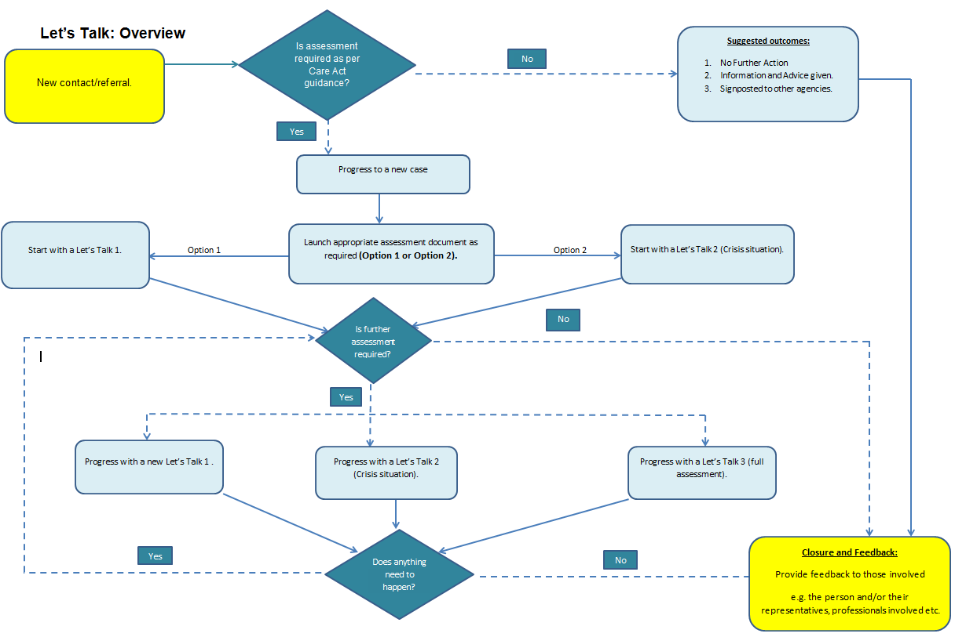

7.7 **New Contact Received**

When contact information is received from other teams and/or services, the contact record needs to be completed for either a new or existing person; section 1 will cover the process for adding a new person’s contact and section 3.2 will cover how to add a contact for an existing person.

7.12 **Assessment- Let’s Talk Forms 1 and 2**

Assessment Conversations Let’s Talk 1 and 2 focus on capturing information about the person and assessing their need. The information captured in Let’s Talk 1 and 2 forms includes information gathered at an initial stage such as;

* Information of the team completing the assessment
* Consent to information sharing etc.

It also includes information on the person such as;

* Their goals and the things they want to achieve
* Their personal resources, abilities, skills, knowledge, potential, etc.
* Their social network and its resources, abilities, skills, etc.

The detailed Liquid Logic processes below will cover the steps to complete the Let’s Talk Forms 1 and 2 forms.

7.14 **Assessment - Let’s Talk Form 3 (Funded Support)**

Assessment Let’s Talk 3 is completed where a person is assessed as needing traditional funded services to meet their identified needs. A full assessment of needs along with financial of the person is required to be completed.

7.16 This section must be read in conjunction with the procedure for securing adult social care funding, which is already in operation and provides a detailed explanation of Trafford Council’s expectations when practitioners are seeking funded care and support.

The detailed Liquid Logic processes below will cover the steps to complete the Let’s Talk 3 form.

7.17 **Detailed Liquid Logic Processes**

7.18 The following screen shots have been reproduced to help provide a step by step guide about how to use the Liquid Logic forms that support the safe, effective and consistent implementation of Let’s Talk.

1. **New Contact for a New Person**

1a. When you receive a new contact in a worktray, the Contact Form will appear. Click on “Outcomes” and the below screen will appear.

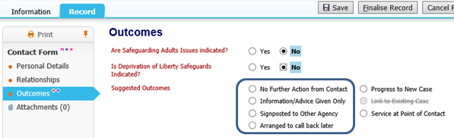

1b. If you are not progressing to a new case, click on one of these outcomes and close the contact by clicking on ‘Finalise Record’.

1c. If progressing to a new case, click ‘Progress a New Case.’

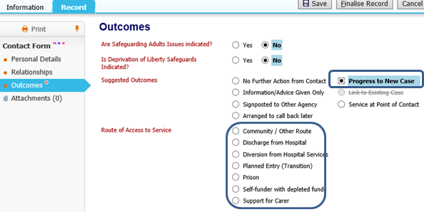

1d. Click one of these options for routes of access to the service and ‘finalise record’.

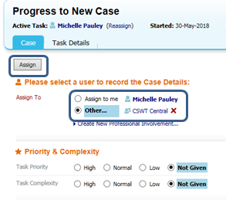

1e. You will then be taken to the next screen to assign the case either to yourself/any team member/team.

1f. Once you have selected the right person click “Assign”

If the case is assigned to yourself, you will see the below screen to start the case.

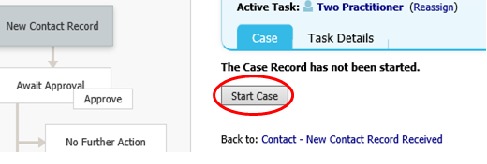1g. Click ‘start case’ to begin the assessment process.

1h. Fill the initial assessment form accordingly.

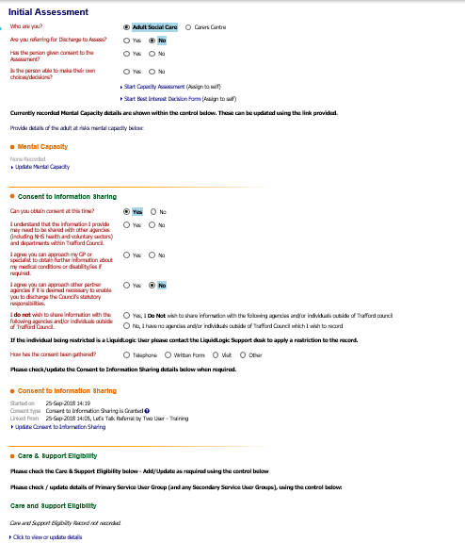

NB: You do not need to complete care and support eligibility at this point.

NB. To update consent to information sharing see 1.i.

1i. To update Consent to information sharing click on *‘update consent to information sharing’* in screen 1. This will take you to screen 2 where you can update the information. Once completed click on update and this will take you to screen 3 to save the and close the information.

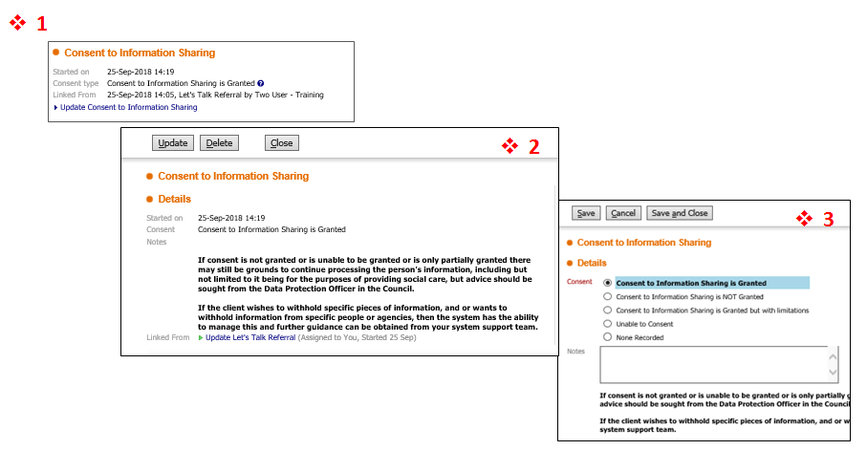

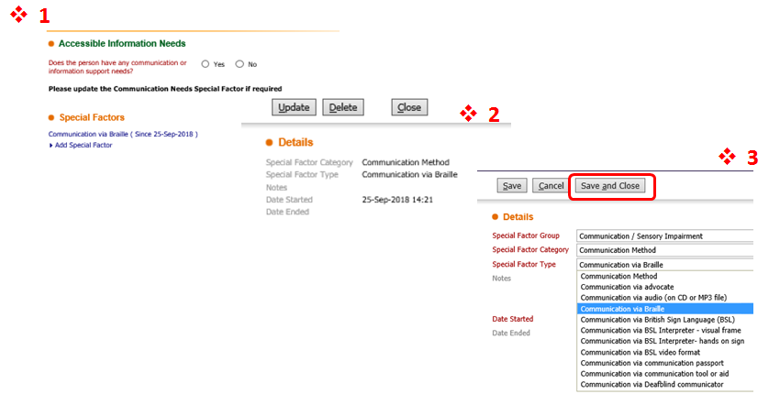1h. For any special communication support need, click *‘add special factor’* on figure 1 below. This will take you to figure 2 where you can update the information. Once completed click on update and this will take you to figure 3 to save the and close the information

**2. Let’s Talk Forms - New Person**

**2.1 Let’s Talk 1: New Person**

2.1a. To progress to Let’s Talk 1 form, click “yes” on the last question of the initial assessment form. This will bring you to the screen below. Complete the forms accordingly, save when required and finalise when completed.

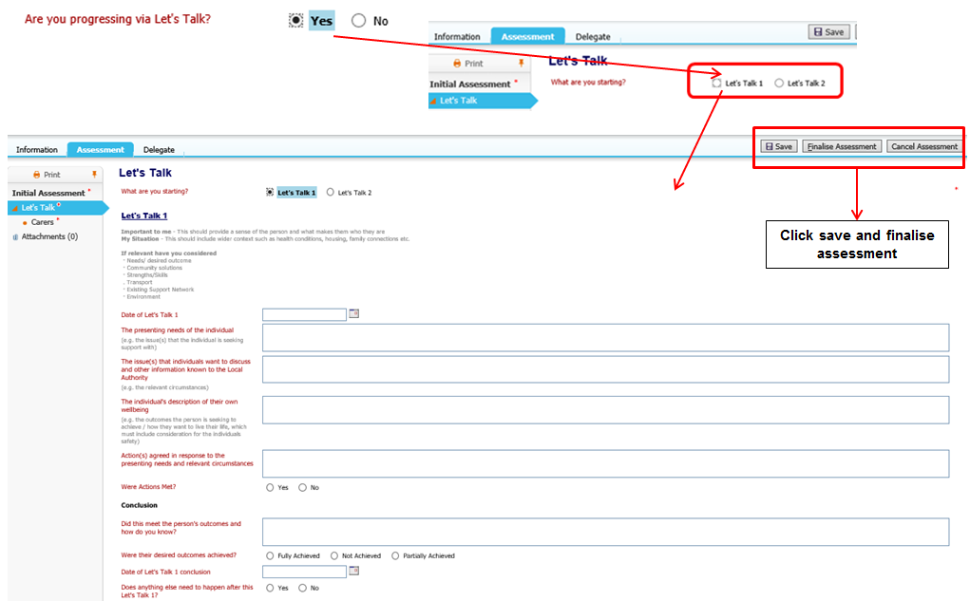

2.1b. If an informal carer is involved, complete the form below by clicking on ‘carers’ and filling the form as required.

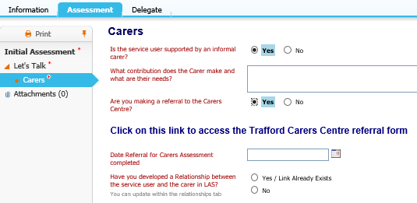

**2.2 Let’s Talk 2 Form- New Person**

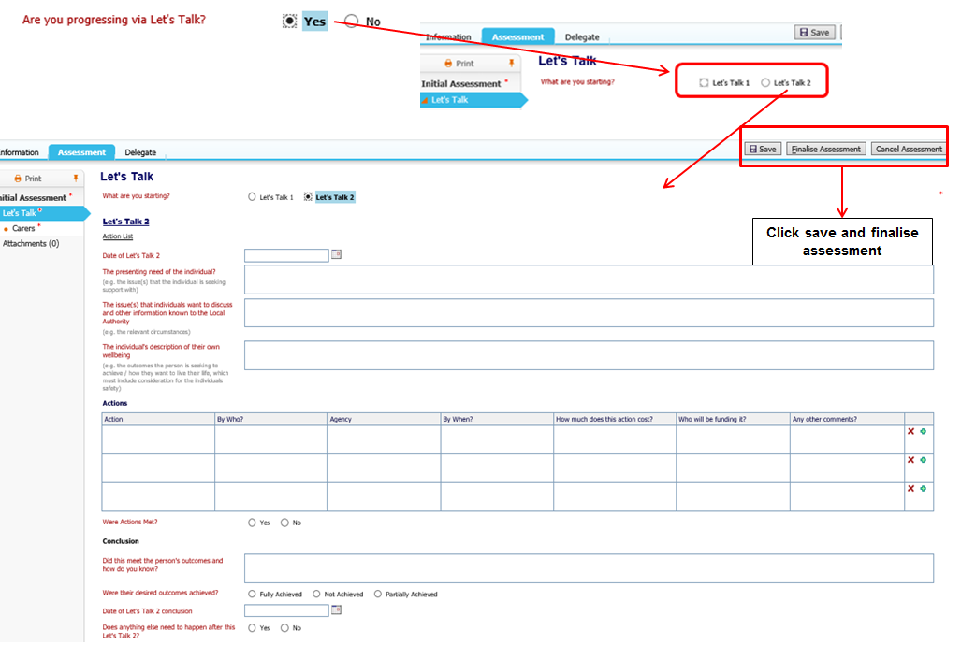2.2a. To progress to Let’s Talk 2 form, click yes on the last question of the initial assessment form. This will bring you to the screen below. Complete the forms accordingly, save when required and finalise when completed.

2.2b. If an informal carer is involved, complete the form below by clicking on ‘carers’ and filling the form as required.



**2.3 Closing a Case - New Person (if you are not progressing to Let’s Talk 3).**

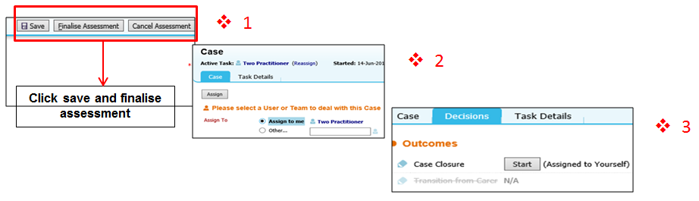2.3a. If you are not progressing to Let’s Talk 3, you will need to click ‘finalise assessment’ on screen 1, this will take you to screen 2 where you can assign the case to yourself. You will then be taken to screen 3; click on ‘decisions’ and then ‘start’.

2.3b. You will then be directed to screen 4, fill the form accordingly then click ‘close case’ on screen 4. On screen 5, select the name of the manager and then click ‘send for authorisation.’

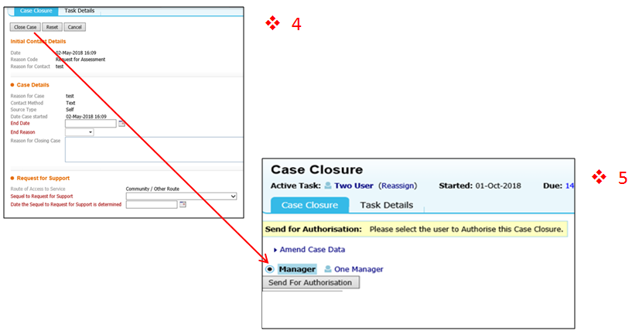

**2.4 Let’s Talk 3 - New Person (If progressing to Let’s Talk 3)**

2.4a. Follow the steps of filling either Let’s Talk 1 or 2 form in step 2.1 or 2.2 and answer the last question which asks *‘does anything need to happen after Let’s Talk 1/2’.* Click ‘yes’ this will bring you to the next question ‘what are you progressing to?’ Click ‘Let’s Talk 3’ and finalise the assessment at the top the form as shown in 2.1a or 2.2a.



2.4b. After finalising the ‘Let’s Talk 3’ form, you will assign the case to yourself to complete as shown on screen 1. This will bring you to screen 2 and you will click ‘start new assessment’.

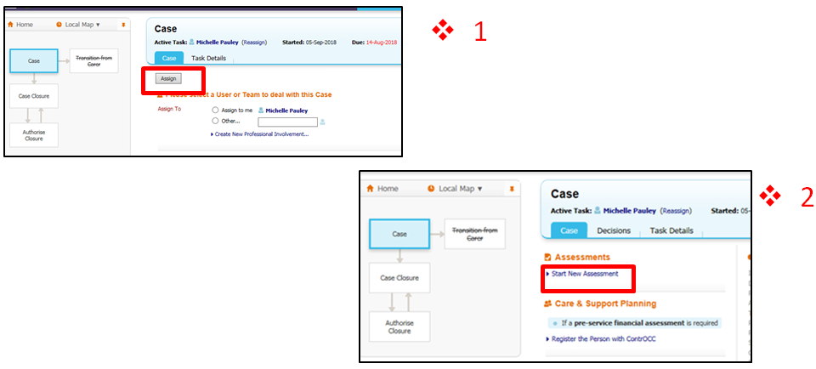

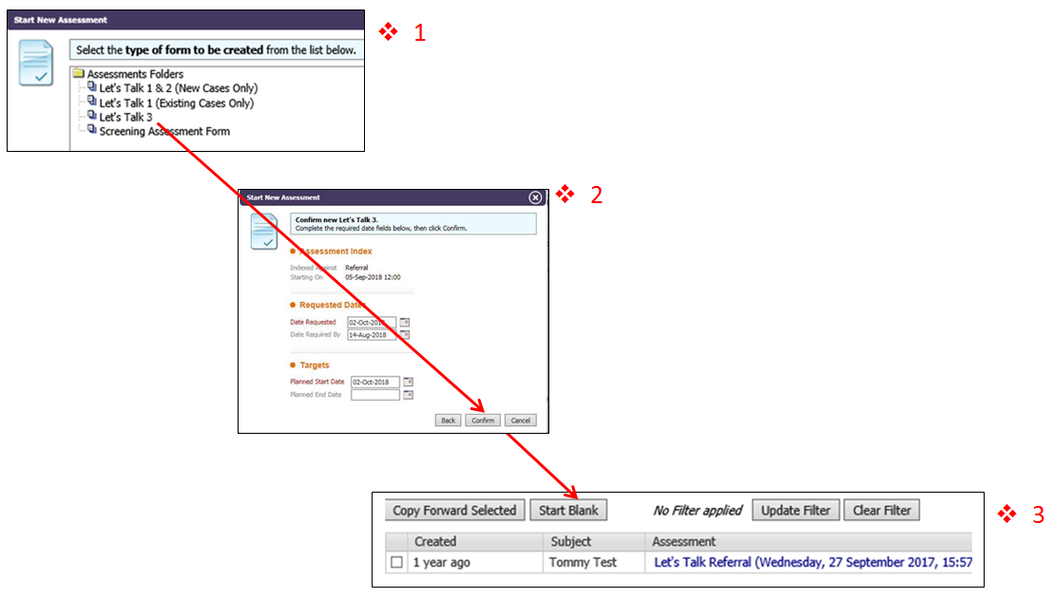2.4c. Click on ‘Let’s Talk 3’ on screen 1 as shown below, fill the form accordingly on screen 2 and click confirm. On screen 3 click on ‘start blank’. This will take you to the Let’s Talk 3 form.

2.4d. Fill the Let’s Talk 3 form accordingly.

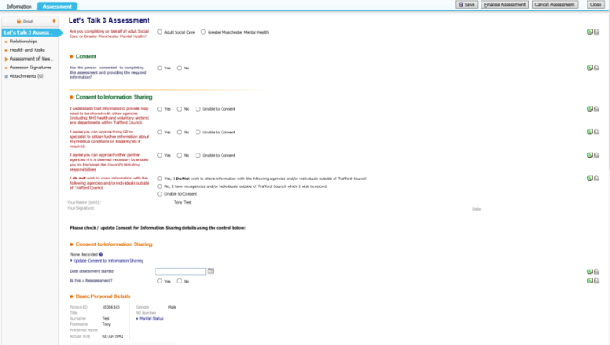

2.4e. Once Let’s Talk 3 is finalised, click on ‘add outcome’ as shown (1), which will bring you to a page where you can ‘add outcome type’. Choose the required outcome type from the dropdown list and click ‘create’ (2). Complete the assessment details accordingly (3). Then click ‘complete assessment’ (4).

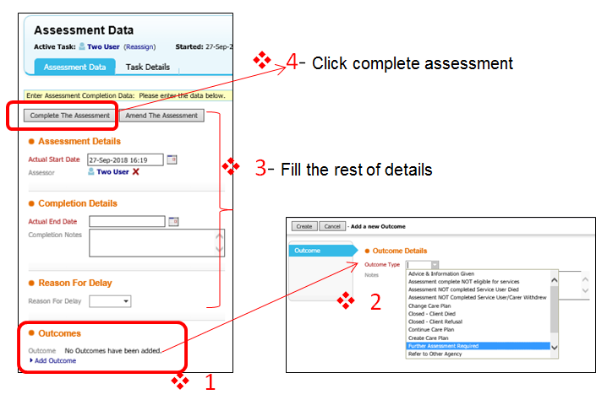

**2.5 Finalise Assessment/Approval Request for New Person.**

2.5a. Click ‘finalise assessment’ on screen 1, this will take you to screen 2 where you can select your manager and then click on ‘send for approval’.

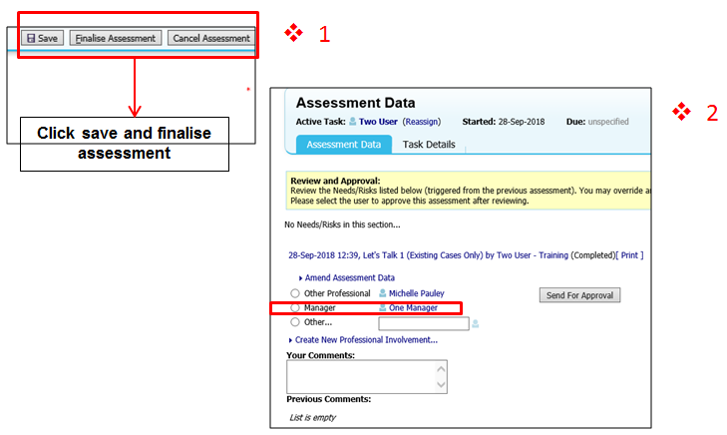

1. **NEW PERSON (if accessing Screening Team functions)**

3.1a. Click ‘start new assessment’ on screen 1, select on ‘Let’s Talk 1 & 2 (New Cases Only)’ on screen 2, fill the form accordingly on screen 3 and click ‘confirm’. On screen 4 click on ‘start blank’.

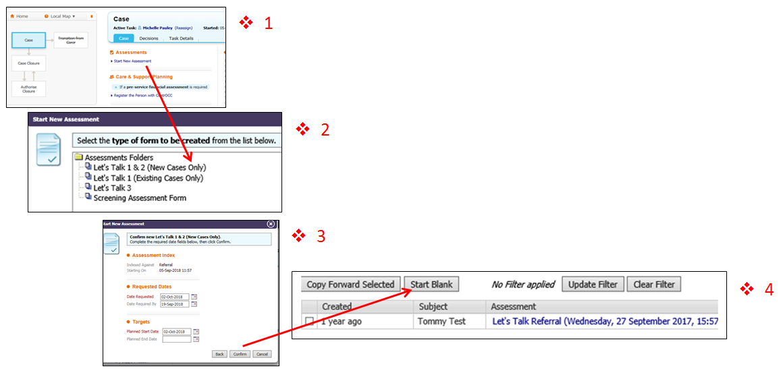

3.1b. Once ‘Let’s Talk 1 & 2 (New Cases Only)’ is finalised, follow steps in 2.4e for assessment completion.

**4. EXISTING PERSON**

**4.1 New contact for an existing person (Crisis Situation)**

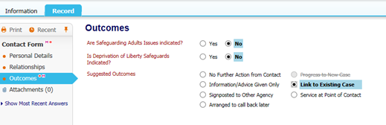4.1a. In a crisis situation, fill a standalone Let’s Talk 2 form. Go to record, and then a Contact Form will appear. Click on ‘outcomes’ and the below screen will appear. Select ‘link to existing case’.

4.1b. Click on ‘case file’ (1), next click on ‘documents’ (2), then in the ‘start form’ select ‘Let’s Talk 2 when a support plan exists’ (3), finally click ‘start’ .

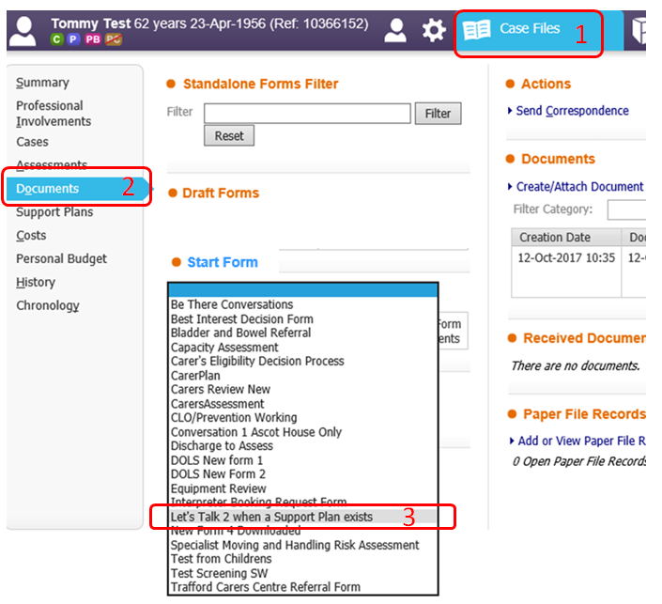

***Note:*** *Let’s Talk 2 cannot be counted as ‘reassessment of needs’ on its own merit. If a reassessment is needed, you will need to follow the steps in section 4.3*

**4.2 New Contact for Existing Person (Non- Crisis)**

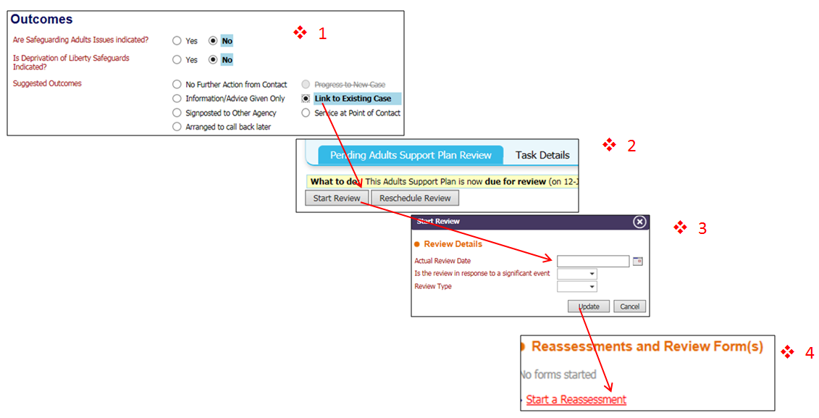4.2a. When you receive a new contact for an existing person in worktray, go to record, then a Contact Form will appear. Click on ‘outcomes’ and the below screen will appear as show in screen 1. Select ‘link to existing case’; this will take you to screen 2 where you click ‘start review’. Complete the information accordingly on screen 3 and click update which will take you to screen 4. Click ‘start reassessment’.

**4.3 Reassessment of Needs**

4.3a. Click on ‘Let’s Talk 1 (existing case only)’ on screen 1 as shown below, fill the form accordingly on screen 2 and click ‘confirm’. On screen 3 click on ‘start blank’.

This will take you to the Let’s Talk 1 form as shown in section 2.1; fill the Let’s Talk 1 form accordingly.

*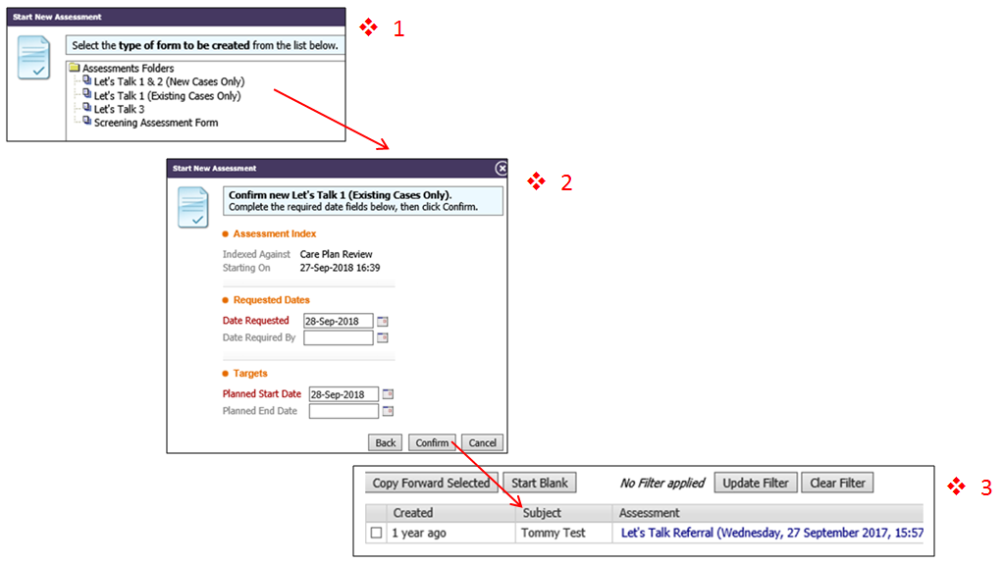****Note:*** *As this is a reassessment of needs, you should consider updating eligibility criteria (under the Care and Support Eligibility & Primary Service User Group) if a change is required.*

***Note:*** *As part of the reassessment, Let’s Talk 1 form will need to be finalised prior to any further assessment. You can do this by clicking ‘Finalise Assessment’ at the top the Let’s Talk 1 form.*

4.3b. Continue filling the details accordingly and click ‘add outcome’ on screen 1, this will take you to screen 2 where you can choose the relevant ‘outcome type’ and once finished; click ‘create’ on screen 2.

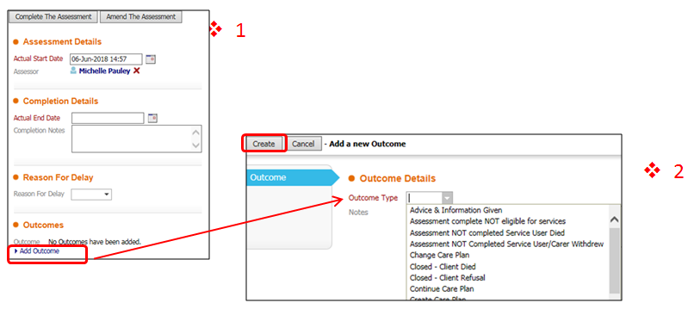

4.3c Once the Let’s Talk 1 (existing case only) is completed, follow the steps in 2.5a to send it to your manager for approval/authorisation.

**4.4 Further Assesment- Existing Person**

Following the completion of Let’s Talk 1 (for existing person) as shown in section 4.3; if further assessment is required the following steps can be undertaken.

**4.4a. Option 1 (Additional Let’s Talk 1- Existing Case)**

On the outcome type click on ‘further assesment required’ in screen 1, then click create.This will take you to screen 2, click on ‘start a reassement’. This will take you to screen 3, select ‘Let’s Talk 1 (existing case only). This will take you to Let’s Talk 1 form shown in section 2.1 which you can fill accordingly.

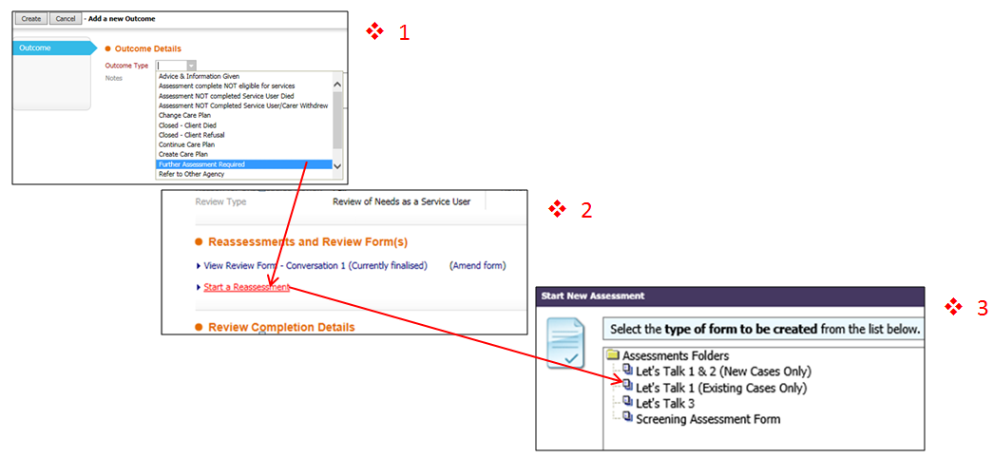

**4.4b. Option 2 (Let’s Talk 3)**

Click on ‘further assessment required’ in screen 1, then click ‘create’.This will take you to screen 2, click on ‘start a reassessment’. This will take you to screen 3, select ‘Let’s Talk 3’. You will then be directed to Let’s Talk 3 form shown in section 2.4d which you can fill accordingly.

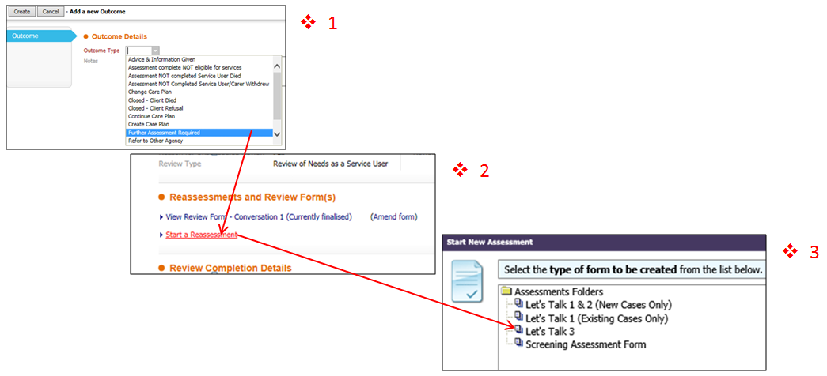

**4.5 Finalise Assessment/Approval Request for Existing Person**

4.5a. To finalise the assessment, follow the steps in section 2.4e - 2.5a.

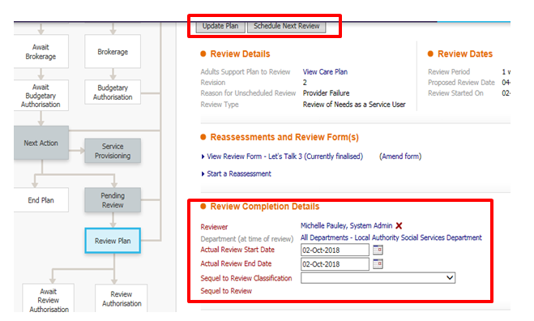4.5b. When approved, complete the ‘Review Completion details’ and either ‘Update Plan’ or ‘Schedule Next Review’.

**END OF GUIDANCE**

**Appendix A: Life Stories**

**Life Story 1 : Let’s Talk 1**

JP is a young woman who has severe epilepsy which has a significant impact on her daily life. JP is currently supported by a Personal Assistant, paid for through a funded package of care from Trafford Council. JP contacted the council to ask for advice relating to feelings of social isolation. A social care assessor (SCA) arranged to visit JP to have a Conversation 1, this conversation revealed JP actually didn’t like having a PA accompany her everywhere.

During the Conversation 1, JP expressed that she would like to work, but due to the risk of epileptic seizure in the workplace this was not an option for JP up until the SCA having the time and authority afforded by undertaking a Conversation 1 to explore this. The SCA suggested volunteering as a way to connect JP with the community to meet her need for social inclusion, JP said she was very interested and would like to try other new activities too. By the next visit the SCA had sourced a voluntary placement with the British Heart Foundation as a way to link JP to opportunities to work, having had time and freedom to think differently and explore further as a result of Conversation 1.

The SCA discovered a member of staff at the British Heart Foundation was trained in managing epilepsy and willing to offer a placement for JP. Additionally, the SCA and found art classes nearby.

When the SCA followed up with JP after a short time JP reported she was enjoying life more already and would like her package of care to be reduced from 3 hours to 1 hour a week, due to her being connected to and accessing the community. When feeding back the SCA noted it was refreshing to have the freedom to spend more time with people face to face and it is likely that this outcome would not have been achieved in the previous system due the structured nature of traditional social care assessments. Without the freedom and time to think differently afforded by the 3 Conversation Approach, JP would likely have received general advice around relevant services, perhaps even having her package of care increased to support her to access these services.

Two things to note in this story are that the SCA had been the same member of staff who had assessed this individual previously, which led to funded support being put in place in the form of a Personal Assistant. Through the new approach, we were able to provide a more community based, person centred solution to JP’s needs, wishes, and goals.

**Life Story 2: Let’s Talk 1**

OW and his family were contacted as he was due an annual reassessment for his existing pad support from the Council. OW has significant learning disabilities and requires support with many aspects of his life. Initially a Conversation 1 was planned to help the member of staff, a SCA, take stock of the situation. When the visit took place OW decided not to take part but the SCA spoke with his parents to gather as much information as possible regarding OW’s wants and desires. The parents reported that OW very much enjoys his day care provision and would like this to remain the same, as he is able to meet different people and enjoy time away from his home with his friends. However they were concerned he didn’t have anything to do in the evening and spent a lot of time alone in his bedroom. They went on to mention OW is keen to watch and play snooker. The SCA suggested that OW could benefit from classes at his local social club, which OW was enthused about as it provided an opportunity to share his passion for snooker with others. The SCA then supported him to fill out the application for a membership at the club. Following this OW’s parents accompanied him on two separate visits to look around and were assured that OW could cope with the environment. Finally the SCA accompanied OW on his first proper visit to introduce him to some regulars; in addition the SCA developed a pictorial laminate given as a reminder for citizen to take monies, club pass and chalk etc. OW is now visiting on a regular basis and is one of the top members of the club!

Without the 3 Conversation approach in place, the traditional full assessment of need would have been carried out. As OW would have been deemed to have the capacity to make the decision to not engage with the SCA to reassess his current funded support, this would have continued exactly the same, missing out on the opportunity to connect OW to community assets such as the snooker club. Under the 3 Conversation model, the SCA had the time to utilise one of OW’s assets – his support network in the form of his parents – and explore what OW’s parents thought and connect OW to community assets, supporting him to do the things he likes to do. Furthermore more, the SCA had the time to build OW’s confidence and attend the snooker club with OW in order to familiarise him with his new connections, which constituted a new routine for OW. This provided OW with the opportunity to develop new friends, connections and interests due to his participation in the community, something that likely would not have been able to happen without the 3 Conversation Approach.

**Life Story 3 – Let’s Talk 2**

PJ is a completely independent elderly gentleman who attended Trafford General Hospital for an elective hip replacement. Following surgery he returned home with the SAMS service. During their initial visit the SAMS team raised concerns that the temperature of his home was a risk factor given the lack of movement associated with recovering from major surgery. A recommendation was made to readmit PJ to hospital as a preventive measure. In response a social worker (SW) visited the same day to have a Conversation 2 and create an emergency plan for PJ, taking preventative measures to prevent a hospital readmission and enable PJ to remain independent in his own home – something that was incredibly important to PJ. Whilst having the Conversation 2 it was established PJ had limited means to heat to heat his home, risking deterioration of his physical, mental and emotional health.

Having established PJ had limited means to heat his own home due to financial hardship and lack of a support network during the Conversation 2, the SW procured two heaters (at a cost of £60) within a few hours and set them up to maintain and improve PJ’s wellbeing in the longer term. As a result of the actions taken PJ was able to keep warm, stay in his own home and avoid a hospital readmission, something he wanted to avoid at all costs. The 3 Conversations approach allowed the SW to promote PJ’s independence and enabled him to have the best chance of making a full recovery while remaining in the community.

**Appendix B: Strengths Based Audit Tool**

|  |  |  |  |  |  |  |  |  |  |  |  |  |  |  |
| --- | --- | --- | --- | --- | --- | --- | --- | --- | --- | --- | --- | --- | --- | --- |
|  |  |  |  |  |  |  | |  |  |  |  | |  |  |
|  |  |  |  |  |  |  | |  |  |  |  | |  |  |
| Name of Auditor & Title | | | | Month this audit corresponds to | | | Date audit completed | | | | |
|  | | | |  | | |  | | | | |
| LAS Number | | | | Service user group | | | Team | | | | |
|  | | | |  | | |  | | | | |
| Team Manager | | | | Key/case worker | | |  | | | | |
|  | | | |  | | |  | | | | |

|  |  |  |  |  |  |  |  |  |  |  |
| --- | --- | --- | --- | --- | --- | --- | --- | --- | --- | --- |
| **Benchmarking Principles** | |  |  |  |  |  |  |  |  |  |
| **1. Wellbeing;**, Adherence to Care Act Principles/Consultation/ Empowerment /Personal Choice / |
| Participation / Advocacy / Equality & Diversity / Best Interests / Mental Capacity clearly recorded/ Person centred Approach / Outcome focused |
|  |
|  | |

|  |  |  |  |  |  |
| --- | --- | --- | --- | --- | --- |
| **2. Keeping Safe;** Risk Assessment and Management / Positive and informed approach to risk/ Domestic | | | | | |
| Abuse / Safeguarding concerns / Risk to Others | |  |  |  |  | |  |  |
|  |



|  |  |  |  |  |  |  |  |  |  |  |  |  |
| --- | --- | --- | --- | --- | --- | --- | --- | --- | --- | --- | --- | --- |
| **3. Proportionality;** Response / Level of Intervention / Professional Judgement / | | | | | | | | | |  |  |  |
| Timeliness |  |  |  |  |  |  |  |  |  |  |  |  |
|  | | | | | | | | | | | |



|  |
| --- |
| **4. Partnership;** Information sharing with others and providers/ Consultation / Joint Working / Support/ CHC |
|  |



|  |
| --- |
| **6. Prevention;** Adherence to Care Act Principles/ Sign posting to other relevant service/ Review |
| /Information and Advice/Safeguarding. | |  |  |  |  |  |  |  |  |
|  |



|  |
| --- |
| **7. Carer;** Clearly recorded/ Assessment offered (if refused reason recorded) / Appropriate carer outcome |
|  |



|  |  |  |  |  |  |
| --- | --- | --- | --- | --- | --- |
| **8. Support Planning;** has the following been considered? Maximising Independence/AT/Enablement/I Age | | | | | |
| Well/ADL/Smartcare/Equipment/Physio/OT/Falls Clinic etc. | |  |  |  |  | |  |
|  |



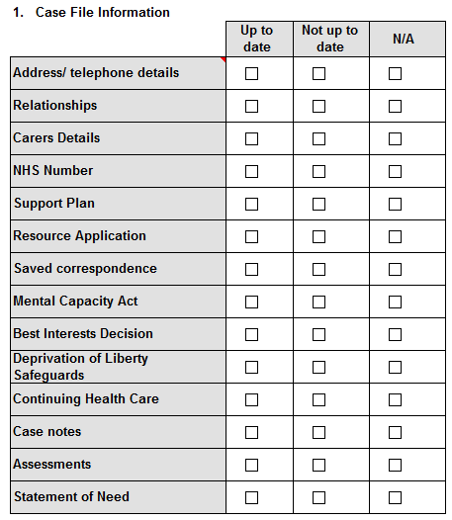

**Trafford – ADASS/PSW Strengths Based Case Audit Tool – Grade Descriptors**

|  |  |  |
| --- | --- | --- |
| **Grade** | **Rationale** | **Commentary and action taken** |
| Excellent | All principles have been considered and acted upon as appropriate with excellent standard of record keeping and supporting documentation. Each category scores excellent on the audit tool. The outcome was appropriate. |  |
| Good | The principles have been considered and acted upon and the customer was actively involved in the intervention as appropriate. The outcome was appropriate. However grading of the intervention would have been strengthened by improved evidence of overall. |  |
| Adequate | Aspects of the principles have not been explored to the degree where the auditor is assured of considered intervention in all principles. The outcome is appropriate. There are training and learning needs identified. |  |
| Poor | In this example there is evidence that the intervention does not meet the principles. The outcome is unsatisfactory. There are training and learning needs identified. The auditor is required to escalate to the relevant Manager within the organisation to seek assurance that support to improve practice is put in place. |  |
| Unacceptable | The auditor cannot be assured that the intervention has met any of the principles to a degree that immediate action is required to seek assurance that the citizen is safe. Immediate Managerial intervention is essential. |  |

Trafford Case File Audit QAF PSW July 2018

|  |
| --- |
| **Feedback:** |
| 1) Any identified areas to consider for practice and learning development: |
| 2) Identified good practice that can be shared wider within the region. |
|  |
| **2. Overall Grade – See Grade Descriptor document** |
| **You must complete the commentary if a case is graded “Poor” or “Unacceptable”** |
| **Auditors** |
|  |
| **ADASS/PSW Network** |
|  |