Adult Social Care

Preparing for Adulthood (PfA) Policy

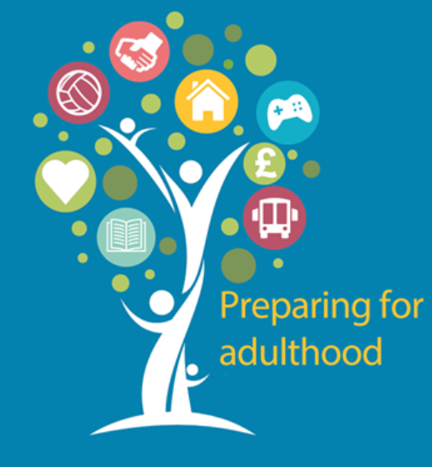

Author: Adult Social Care
Date: June 2023
Version: V1.3

Version | Date | Author | Change History
1.00 | June 19th 2023 | Emma Brown | Document creation
1.2 | June 28th 2023 | Emma Brown
1.3 | June 28th 2023 | Ciaran Cusack | Feedback pathway added
Document History

No. | Name | Role | Date | Issue
1 | Senior Leadership Team | SLT
Document Reviewers

Document Approvals
Name | Role | Date | Version
DASS Assurance | DASS Assurance | June 28th 2023 | 1.3

Date of Next Review
Date | Owner
June 2024 | Emma Brown, Director of Adults

- Introduction

Preparing for Adulthood (PfA) is a term which can be applied to all young people to describe the stage in their lives when they move from being a child into adulthood. However, for the purposes of this policy, Preparing for Adulthood refers to children and young people with an Education Health Care Plan (EHCP) and it is anticipated that they are likely to require additional care and support as an adult.

This document also includes information which applies to the parents/carers of young people preparing for adulthood.

Preparing for Adulthood is a period when young people are able to make informed life choices independently or with support (16 years +). It is a time when they may reflect on what they have achieved so far and what they wish to achieve in the future. There are many decisions to be made and while these may be exciting, they may also be challenging and make young people and their families feel nervous about the future.

This policy sets out Trafford’s commitment to supporting young people who may have the need for additional care and support in adulthood. It reflects Adult Social Care’s approach to best practice across the areas of Education Health and Social Care.

- Principles

What we know ensures that a young person (& their family/carers) are genuinely prepared for adulthood is the following:

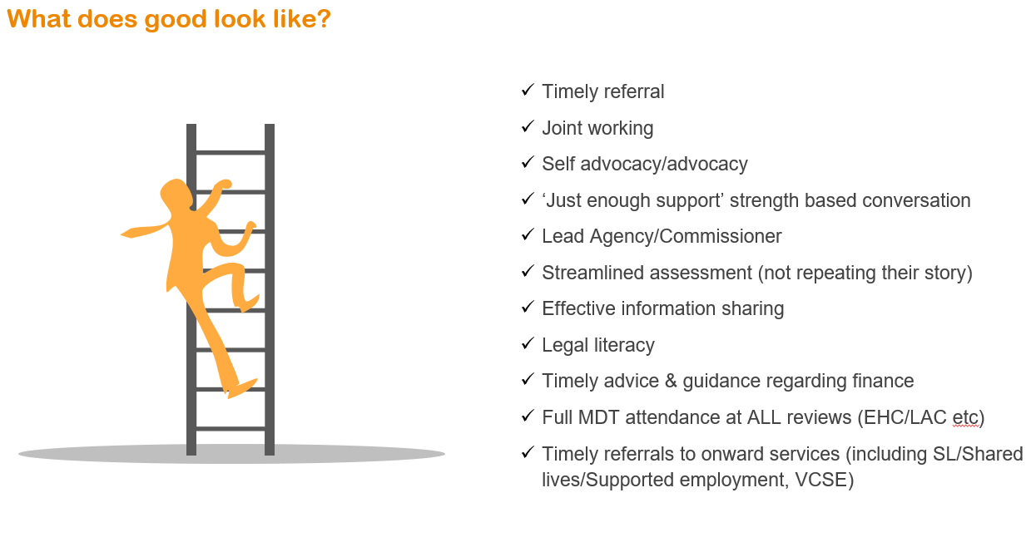

Adult Social Care will;

- Ensure that we have completed a Care Act (2014) assessment no later than 17 years and one month
- Engage with all planning meetings/ EHCP’s (annual reviews)
- Record all our interventions in our case notes in Liquid Logic under the Preparing for Adulthood category
- Adhere to our PfA checklist in all referrals
- Undertake person centred, strength-based assessments
- Ensure that the voice of the young person & their parents/care givers are central to everything we do

- Scope

This policy reflects the commitment from Adult Social Care to work in partnership with our young people and their families collaboratively alongside partner agencies. It outlines how we will all work together, and guides professionals in managing the transition to adulthood for our young people.

This policy describes what should happen and when, who has responsibility, and how agencies should work together.

This policy applies to all young people between the ages of 14 and 25 who have disabilities and/or complex needs and/or who have an Education, Health and Care Plan (EHCP).

It also applies to young people who:

- Are likely to meet the eligibility criteria for adult social care services (in accordance with the Care Act 2014) which may include:
- Young people with Care Planning Approach (CPA) plans;
- Young people with Pathway Plans;
- Young People in receipt of Continuing Care funding;
- Young people known to Children Community Nursing Team (CCNT)
- Young people know the youth justice system

- Those who would benefit from support in planning for adult life but do not have an Education Health Care Plan/Special Educational Needs (e.g. those with high-functioning autism or social/emotional/mental health difficulties/ill health);

- Carers of young people preparing for adulthood and young carers who are themselves preparing for adulthood

- Complex Safeguarding

- Aims and Outcomes

The following sections provide detail of relevant legislation and guidance outlined to ensure that all young people and their families/carers have a planned and positive experience of transition.

The four National Outcome measures for Preparing for Adulthood are as follows:

Health & Wellbeing:

A young person will be supported in optimising their emotional and physical well-being. They will engage / be supported to complete self-care routines and will recognise the need / be supported in for dental, medical, and optical health and will attend routine medical appointments as required. A young person will make healthy eating choices and also have physical activity and physical well-being promoted

We will ensure that Health & Wellbeing is a conversation explored with every young person every time we meet
We will ensure that every young person /adult has access to the Health & Wellbeing services they require within a reasonable time frame and where this cannot be achieved the reason for delay is communicated to them personally (in person ,telephone etc)
We will ensure that all young people/adults considered to have a learning disability receive an annual Health check age 14 years+
We will ensure that all of workforce who are undertaking assessments with people presenting with needs associated with autism are suitably trained/skilled to do so
We will ensure that all young people with SEND all have a Health 'Passport' should they require reasonable adjustments in a hospital setting
We will ensure that all young people/adults receive an annual re-assessment of their needs
We will ensure that when a young person/adult is in receipt of Continuing Care, a Continuing Health Care (CHC) 'checklist is completed by 17.5 years of age
We will increase our personalised care offer either via an ISF, Direct Payment or Personal Health Budge.
We will ensure that all our young people/adults have a personalised support plan detailing how their care & support needs will be met
We will ensure that all young people/adults who may be experiencing mental wellbeing issues are identified at the earliest opportunity and supported

Independence:

A young person will be able to access community, leisure and social facilities to participate in their local community and access appropriate transport in order to facilitate this (this includes showing awareness of risk (travel, road safety, personal safety) in the context of community participation in order to remain safe.

We will ensure that we focus on our young people’s aspirations and wishes/views to promoting independence which is reflected in their Support/Independence plan
We will ensure that all young people are offered ISFs, DPs and personal budgets to increase their choices and control over their own lives
We will develop a marketplace . both face to face of different opportunities and providers so that young people and their families can familiarise themselves with opportunities and services available to them when they begin adulthood.
We will ensure that all young people/adults are provided with modern technology to maximise their independence where possible
We are committed to reducing our admissions to permanent residential care to ensure our people can remain living well in a place they consider to be their home for as long as possible
We will increase our accommodation options for young people adults to maximise their indepdence
We will ensure that our Community Link Officers build on any travel training undertaking as a child
We will increase the outcomes of our young people/adults who no longer require specialist service intervention
We will ensure that all our young people/adult outcomes are compliant with the legal frameworks which professionals are duty bound to work within
We will ensure that our communications & engagement is based on the young person/adults preferred method of communication

Employment/Higher Education & meaningful Occupation:

A young person will be able to access and function within work settings (i.e., voluntary work / community-based projects and paid employment).

We will increase the number of young people/adults who are in employment (paid or on a voluntary basis)
We are committed to a decrease in traditional 'day service' uptake as we invest more so in our local community resources, increasing opportunities and maximising community connections and friendships.
We will increase our ability to deliver person centred 'outcomes' for young people and adults by commissioning differently
We will develop our supported internship offer
We will expand our apprenticeship model to young people/adults
We will develop a pathway for our volunteers to become Personal Assistants (Direct Payments/Personal Health Budgets)

Family, family, friend & community connections:

A young person will maintain their family connections, be supported to access peer networks that will maintain , develop and extend existing friendship and relationships. A young person will be supported to have information / knowledge and awareness of their own community and what is happening so that they can fully participate.

We will ensure that we always focus on our young person/adult strengths
We will always ensure that we explore natural support and local community options for our young people/adults before providing specialist support/intervention
We will ensure that where a safeguarding concern is raised, that this is personalised to the young person /adult
We will ensure that young people/adults have access to leisure facilities which are accessible
That all of our young people/adult carers have access to our Carers centre and receive an assessment of their own needs (where appropriate)
We will ensure that young people/adults have access to appropriate support at a time which is right for them and their parents/carers

Ensuring that all of our conversations with young people focus on these four areas is essential as the young person/adult’s Support/Independence Plan is co-produced.

- Legislation and Guidance

Together, The Children & Families Act, 2014 (hyperlink required) and The Care Act ,2014 (hyperlink required) provide a comprehensive legislative framework for the transition from children to adult services for those with care and support needs.

It is important to note that the Children & Families Act introduced a system of support from birth to 25 years and the Care Act is concerned with those aged 18 or over; therefore, there is a group of young people aged 18-25 who are entitled to support under both pieces of legislation.

The duties from both Acts are placed on local authorities, not children’s and adults’ services separately; therefore, joint working is vital to ensuring smooth transition. Both pieces of legislation have a shared focus on;

‘Person-centred and outcome-focussed approaches that involve young people and their carer’s, recognising that transition is a process experienced as a family rather than an individual’.

It is also essential that transition is indeed seen as a planned process evolving gradually from ages 14 to 25

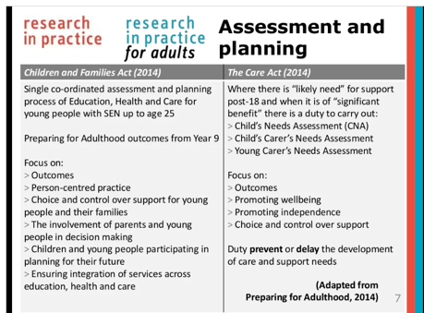

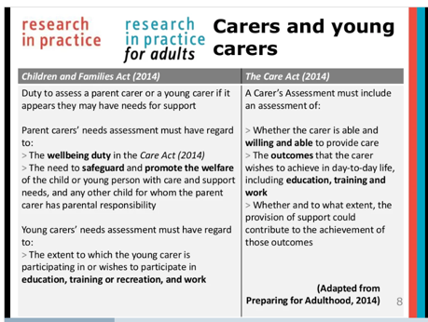

- The Care Act 2014: Preparing for Adulthood process

As a young adult’s eligible social care needs shall predominantly be met under The Care Act, (2014); this is the foundation of which this policy has been developed.

The Care Act: Wellbeing principle

The Care Act, 2014 is underpinned by the principle that local authorities must promote an individuals wellbeing in relation to the following nine areas:

- personal dignity (including treatment of the individual with respect)
- physical and mental health and emotional wellbeing
- protection from abuse and neglect
- control by the individual over their day-to-day life (including over care and support provided and the way they are provided)
- participation in work, education, training or recreation
- social and economic wellbeing
- domestic, family and personal domains
- suitability of the individual’s living accommodation
- the individual’s contribution to society.

Whether an individual’s need for care and support can be reduced, delayed or prevented must also be considered.

Adult social care eligibility criteria (Care Act 2014)

An adult (or young person soon to be 18) meets the eligibility criteria if:

- their needs are caused by physical or mental impairment or illness
- as a result of their needs they are unable to meet 2 or more of the eligibility outcomes (see below)
- as a consequence of not meeting identified needs, there is likely to be a significant impact on their wellbeing.

Eligibility outcomes
- Managing and maintaining nutrition
- Maintaining personal hygiene
- Managing toilet needs
- Being appropriately clothed
- Being able to make use of the adult's home safely
- Maintaining a habitable home environment
- Developing and maintaining family or other personal relationship
- Accessing and engaging in work, training, education or volunteering
- Making use of necessary facilities or services in the local community, including public transport, and recreational facilities or services
- Carrying out any caring responsibilities an adult may have for a child

Being unable to achieve an outcome includes any circumstances where the adult is:

- Unable to achieve the outcome without assistance.
- Able to achieve the outcome without assistance but doing so causes the adult significant pain, distress or anxiety.
- Able to achieve the outcome without assistance, but doing so endangers or is likely to endanger the health or safety of the adult, or of others.
- Able to achieve the outcome without assistance but takes significantly longer than would normally be expected.

The Care Act (2014) and Preparing for Adulthood

The Care Act specifies 3 situations where there is a likely need for care and support:

- Children likely to need care and support after turning 18 and into adulthood.
- Adult carers of children who will be turning 18 and who likely to have ongoing care and support needs.
- Young carers who will themselves be turning 18.

Young People likely to need care and support into adulthood

The Preparing for Adulthood pathway runs from age 14 (year 9) to 25. Central to preparation for adulthood is the Education Health Care Plan and the Preparing for Adulthood annual reviews. It is within the Education Health Care plan that the preparation for adulthood outcomes below are identified and measured:

• Employment/Meaningful occupation: – is a spectrum of outcomes including full or part time employment, becoming self-employed and help from supported employment agencies, accessing higher or further education, apprenticeships, volunteering or achieving meaningful activities.

• Independent Living – is young people having choice, control and freedom over their lives and the support they have, their accommodation and living arrangements, including supported living

•Community Inclusion- is participating in society, including having friends and supportive relationships, and participating in, and contributing to, the local community

• Health & Wellbeing- Being as happy & healthy as possible in adult life

Local authorities can meet their statutory duties around transition assessment through an annual review of a young person’s Education Health Care Plan that includes:

- current needs for care and support
- Where the young person has a special educational need identified in an Education Health Care Plan, the individual healthcare plans should be linked to or become part of that EHC plan.
- whether the young person is likely to have needs for care and support after they turn 18, and;
- if so, what those needs are likely to be and which are likely to be eligible needs

The Preparing for Adulthood annual review must involve the young person and anyone else they want to involve in the assessment. They must also include the outcomes, views and wishes that matter to the young person – much of which will already be set out in their EHC plan.

Adult carers of children who will be turning 18 and who likely to have ongoing care and support needs

Where the carer requests or consents and the local authority believes it to be of significant benefit to do so, a carers assessment will be carried out to see whether the carer of a young person has needs for support and what these needs will be once the young person reaches to age of 18.

Adult carers eligibility framework

The carer shall be deemed to have eligible needs if:

- Their needs are caused by providing necessary care for an adult
- Their health is at risk
- Or they are unable to achieve any of the specified outcomes (see list below)
- As a consequence there is likely to be a significant impact on their wellbeing.

Adult carers eligibility outcomes
- Carrying out any caring responsibilities the carer has for a young person
- Providing care to other persons for whom the carer provides care
- Maintaining a habitable home environment in the carer’s home, whether or not this is also the home of the adult needing care
- Managing and maintaining nutrition
- Developing and maintaining family or other personal relationships
- Engaging in work, training, education or volunteering
- Making use of necessary facilities or services in the local community, including recreational facilities or services
- Engaging in recreational activities

Being unable to achieve an outcome includes any circumstances where the carer is:

- Unable to achieve the outcome without assistance.
- Able to achieve the outcome without assistance but doing so causes significant pain, distress or anxiety.
- Able to achieve the outcome without assistance, but doing so endangers or is endanger the health or safety of themselves or any adults or young person for whom they provide care.

The Carers Centre will undertake Carers Assessments for adult carers of young people who will be turning 18 and who likely to have ongoing care and support needs.

- Relevant Policies and Procedures

Where applicable, this policy ought to be considered in conjunction with:
- The PfA Landmarks website which details the applicable timelines, policies, protocol’s and individual service mechanisms for a young person’s PfA journey. (NDTi)
- Trafford’s SEND Policy and Education, Health and Care (EHC) processes (SEN led)
- Local children’s / adult’s safeguarding policies
- Looked after Children and Pathway Planning (Care Leavers)
- Care Programme Approach ( CPA - Mental health and / or learning disability)
- Trafford’s Autism Strategy
- Trafford’s Continuing Healthcare transition pathway.

This policy reflects, The Care Act, 2014, The Children & Families Act, 2014 and Special Educational Needs and Disability (SEND) Code of Practice, 2014.

- Young People likely to need care and support into adulthood

Involving the young person

The concept of co-production is central to both the Care Act (2014) and Children and Families Act (2014) and therefore underpins this Preparing for Adulthood protocol. By 16 years, if not earlier, we recognise that professionals should be directly engaging with young people to ensure that they are being listened to and fully involved in planning and decision-making. 14 at the latest for long term conditions as per NICE guidance (2016).

The rights of young people to make decisions is subject to their mental capacity to do so and at 16 years old is defined by law, specifically the Mental Capacity Act 2005. The five principles of the Act are;

- Presumption of capacity
- Support to make a decision
- Ability to make unwise decisions
- Best interest
- Least restrictive

NB: The 4th and 5th principles apply only when a person has been assessed as not having mental capacity for the decision in question. Whilst it is not a principle of the Act, it is essential to remember that mental capacity is time and decision specific.

The right of young people and families to be involved in decisions and planning is also found in Section 19 of the Children and Family Act 2014 which states:

19 Local authority functions: supporting and involving children and young people.
In exercising a function under this Part in the case of a child or young person, a local authority in England must have regard to the following matters in particular—

(a) the views, wishes and feelings of the child and his or her parent, or the young person;
(b) the importance of the child and his or her parent, or the young person, participating as fully as possible in decisions relating to the exercise of the function concerned;
(c) the importance of the child and his or her parent, or the young person, being provided with the information and support necessary to enable participation in those decisions;
(d) the need to support the child and his or her parent, or the young person, in order to facilitate the development of the child or young person and to help him or her achieve the best possible educational and other outcomes.

System

We are developing an ‘outcome tool’ which will be embedded into Liquid Logic (Adults). This tool is intended to be conversational and focuses on the four National Outcome detailed in section 4.

9. Voice of Our People

As part of the Adult Social Care Customer Feedback Strategy 2022-2025 the Voice of Our People is our mechanism in seeking the views and experiences of those using Adult Services.

This work is co-ordinated through our ICE Team who collate feedback from surveys on people’s experience of ASC services and if their outcomes were met.

Development of specific Pfa feedback methods is presently underway.

We will look to embed the Voice of our People work into PfA and ensure that we use this approach to understand people’s experiences to inform improvements to our PfA service.

- Preparing for Adulthood: Referral

The Preparing for Adulthood referral tool is based upon the Eligibility Criteria of the Care Act and helps the young person, their family, and professionals to understand how care and support is defined by law. If it was felt to be of significant benefit to the young person, then a Care Act Screening Tool can be used to help identify if the young person is likely to receive care and support from Adult Social Care as an adult.

For Social Care referrals, this tool is embedded into the Children’s LCS primary recording system and is mandatory for all young people who are perceived to have care and support needs as an adult.

From year 9 onwards (age 14 +), young people (or parents/advocates/professionals) with EHCP’s could complete a Preparing for Adulthood referral, if it is felt it would be of significant benefit. This can occur anytime between years 9 to 12 but should be particularly considered at the year 9 (age 14) and year 11 (age 16) reviews and be part of the multi-agency considerations.

Following completion of the Preparing for Adulthood Care referral, this will clearly identify the identified Pathway for the Young Person.

For Adult Social Care these will be either;
- Complex (Learning Disabilities)
- Neighbourhood (all other young people)

Upon receipt of the Preparing for Adulthood referral (via Liquid Logic) it is expected that the majority of the information required to successfully manage the transition from children’s to adult services will be found in the Education Health Care Plans (EHCP’s). However, if the Adult Social Care Team Manager/Senior Practitioner believes it would be of significant benefit then they may request additional information from the referrer and invitations to key meetings (dependant on age, risk and needs).

The Preparing for Adulthood referral is completed jointly by the young person /parent /Advocate/ lead professional.

Adult Social Care provides all interventions underpinned by our Let’s Talk model. Let’s Talk is a strength-based approach to engagement which focuses on personal and community assets. Adult Social Care may offer direct or indirect support to ensure the young person’s aspirations and goals are achieved. All information obtained by Adult Social Care would be included in the person’s EHCP so that the young person, parents, and other interested parties are aware of the young person’s outcomes, potential needs and available support once they turn 18 years old at the very least at 17 years and 1 month.

Young people (age 16 plus) do have the right to not provide Adult Social Care with consent to share their identified information with others (including their parents). However, this refusal to consent can be overridden where there are perceived safeguarding concerns or wider public interest matters. Any information which falls into these criteria would always be shared proportionately with the appropriate professionals involved in the young person’s care in the first instance. Any young person who lacks decision making capacity regarding information sharing; any decision to share would always be considered in their best interests (in accordance with the Mental Capacity Act, 2005).

In addition to the Preparing for Adulthood referral the following are to be discussed with the young person’s parents/car providers:
- is the parent / carer able to care now and after the child in question turns 18?
- is the parent / carer willing to care now and will continue to after 18?
- does the parent / carer works or wishes to do so?
- does the parent / carer participate in education, training or recreation or wishes to do so?
- Has the parent received a carers assessment in their own right?

- Preparing for Adulthood: Pathways

From year 9 (age 14 years), consideration needs to be made whether a young person is perceived to have care and support needs in adulthood. Care and support needs could derive from; educational, health, housing or social care needs. It is probable that the young person is known to at least one agency and preparation would be undertaken through Education, Health and Care Plans (EHCP), Care Planning Approaches (CPA), Child in Need, Pathway Planning, Continuing Healthcare, or similar.

For those young people whom it is deemed likely to need care and support into adulthood then a determination is made at Year 9 or following which Preparing for Adulthood Pathway they should follow. There are three PfA Pathways:

- PfA Independence Pathway
- PfA Neighbourhood Pathway
- PfA Complex Needs Pathway

These pathways correspond to the anticipated adult support destination of the young person when they reach 18 years.

It may not be possible at year 9 to determine the correct Pathway for the young person or it may be that additional information may be required; however, transfer later between Pathways is possible, but must be no later than the young person reaching 16.5 years.

    - PfA Independence Pathway

The Independence Pathway is for young people with an EHCP but are unlikely to need care and support into adulthood. This is determined by the Preparing for Adulthood referral checklist undertaken following Year 9 (age 14+). It would be advisable to review this checklist at year 11 (age 16 years) to see if the young person’s needs have changed.

Young people on the PfA Independence Pathway may not require multi agency reviewing processes as they may be known to only a single agency. Some young people may have multi-agency approaches delivered through Early Help / Child in Need / Child Protection. In these circumstances the PfA EHC outcomes should be shared with the agencies involved to help inform their planning. For young people known to the Short Break Team the PfA EHCP should form part of the discussions with parents and the young person about how the personal budget / direct payments can be used to support those outcomes.

    - PfA Neighbourhood Pathway

This Pathway is for young people 16+ who are likely to need care and support into adulthood and those interventions will be delivered through the Adult Social Care Neighbourhood Teams or our Greater Manchester Mental Health (GMMH) Service. This will be determined by the Preparing for Adulthood checklist tool at year 9 and confirmed at year 11 (unless referral required earlier due to needs and/or risk). This support may be delivered by exploration of a person’s individual and community assets from an Adult Social Care perspective or by adult health services.

This would be dependent on individual transition protocols and eligibility criteria for each service. It is likely that the young person’s future needs for care and support arise from or are related to a physical or mental impairment or illness and are not caused by other circumstantial factors.

Young people on the PfA Neighbourhood Pathway are likely to have multi agency reviewing processes either social care as a Looked After Child or Child in Need or health due to social, emotional, and mental health issues. It is likely their future needs for care and support arise from or are related to a physical or mental impairment or illness and are not caused by other circumstantial factors.

The young person is likely to need specialist support in adulthood due to; autism, mental health associated needs, ADHD or learning difficulties meaning they may require care and support into adulthood.

All young people perceived to have a primary need of mental health ought to be referred to Greater Manchester Mental Health (GMMH) services via the monthly Neighbourhood Planning meetings.

If the young person has a diagnosis of autism and they are on the Dynamic Support Register and categorised as amber or red, then consideration should be given as to whether they should be placed on the Complex Needs (Enhanced) pathway.

If the young person has a diagnosis of a learning disability, then they should be supported by the Complex Need pathway.

The Neighbourhood Pathway meeting will be Chaired monthly by an Adult Social Care Service Manager representative in co-chair arrangements with Partner agencies.

    - PfA Complex Needs Pathway

This pathway is for young people 16+ who are considered to have a Learning Disability who are likely to need care and support into adulthood and those services will be delivered through the Complex Needs (adult social care and health) Team. That support may be delivered by either or both adult social care or adult health services subject to the individual transition protocols and eligibility criteria for each service.

Young persons identified as amber or red on the Dynamic Risk Register, are moved into the Complex Needs Pathway. Complex Needs Planning continues but will also include the NHS Trafford Integrated Care Services (ICB), commissioners and this will run in conjunction with the CETR (Care, Education and Treatment Review) or Care Treatment Review (CTR) processes where appropriate. The Complex Needs Pathway is triggered by a request for a multi-Disciplinary team (MDT) meeting.

The Complex monthly Pathway meeting will be Chaired by one of the Community Learning Disability Leadership Team in co-chair arrangements with Partner agencies.

Complex Safeguarding

Young people who have protection needs going into adulthood (e.g. complex safeguarding) and who also have EHCP ought to be known to the respective Neighbourhood tracking team’s through the Care Act Screening Tool . The need for ongoing care and support will be identified at y11 by the Preparing for Adulthood referral tool.

Irrespective of the Pathway status of the young person and whether they are known to the Neighbour Tracking Panel, an Adult Safeguarding Referral is to be made by the children’s social worker at the latest 16 ½ years old. Joint Multi-Disciplinary Meetings will then take place upon receipt of the Safeguarding notification to Adult Social Care. It may be necessary for the Children’s Social Worker to continue to remain involved with the young person beyond their 18th Birthday to support the transition.

Adult Social Care have s a Safeguarding Hub which has developed strong relationships with the Complex Safeguarding Children’s Team (SHINE).

Operational Escalation Group

The Operational Escalation group will take place monthly and will be Chaired by the Service Manager of the Community Learning Disability Team.

This meeting will oversee any matters pertaining to risk or thematic matters deriving from the Complex or Neighbourhood monthly meetings.

Each meeting will collate a highlight report which will be made available to the Preparing for Adulthood Board.

Preparing for Adulthood Board

The Preparing for Adulthood Board consists of strategic partners across children’s and adult services. The Board will be the escalation point for any themes/risks which cannot be manged at an operational level.

SEND Board

The SEND Board is the assurance Board for all matters relating to the Ambition plan, for which Preparing for Adulthood is ambition 4 (of 6).

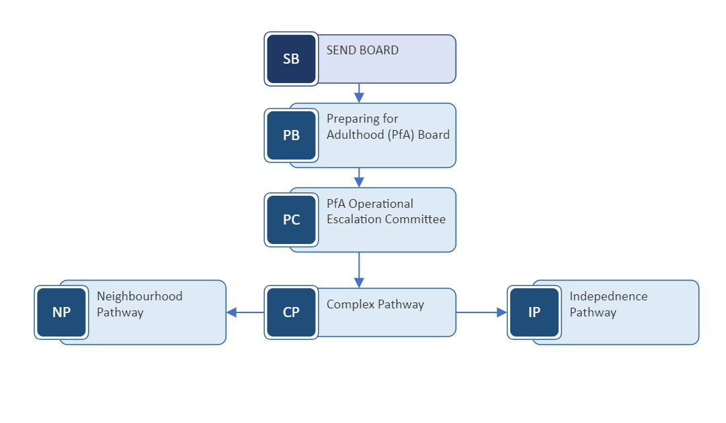

Preparing for Adulthood: Review meetings

As per the Children & Families Act 2014 every EHC Plan review from year 9 onwards must have a focus on Preparing for Adulthood. Planning for those young people with EHCP takes place as part of the statutory annual review process, which is arranged by schools and is monitored by the Council’s SEND Service.

The function of the review meeting will be:

- To review and reflect on the Education, Health and Care Plan and celebrate the outcomes achieved.
- To look at the different options available for the future;
- Discuss the young person’s hopes aspirations and what may be required to help them take the next steps towards adulthood;

The outcomes set for the young person should be based around the four PfA outcomes of:
- Employment
- Independent living
- Community Inclusion, family, family & friends
- Health & Wellbeing

All reviews should be conducted in a person-centred manner to ensure that the young person is kept at the centre of decisions about their life. At this review it is expected the following professionals will be informed of the review and invited to attend or provide an update as to how their service is meeting or likely to be involved in meeting the outcomes of the young person:

- Involved health care services
- Speech and language therapists
- Physiotherapy
- Occupational therapy
- Dietician
- Children Community Nursing team
- School nurse
- Consultant paediatricians
- Involved social care services
- Social worker
- Social care reviewing officer
- Adult services representative when required
- Others to be considered
- Interpreter
- Advocates

At these reviews the needs and wishes of the young person /adults’ carers should be considered with parent / carers being offered the opportunity to receive a carers assessment. The EHC reviews should also include future aspirations, residence, and work / education arrangements.

The outcomes of the review meeting are available to the Neighbourhood / Complex Needs teams through the online EHC workspace in Liquid Logic Early Help module.

Age Stages – What Happens and When

Within a 6 week period of turning 14 a supporting person (School / College / EHC Coordinator / Social Worker) identifies that you will likely require social care support in adult life they will gain consent to extend an invite for a representative from Adult Services to attend a planning meeting or annual review

Year 9
Aged 14-15

Where a young person’s support is complex or high cost then a representative will commence attendance at annual meetings and reviews to alert commissioning colleagues and other agencies of predictive planning and support

YEAR 10
Aged
15-16

Identified representatives within child and adult services (encompassing Education Health or Care) will coordinate a planning discussion with a young person and representatives to discuss action planning and next steps following a what / who / when outcome focused model

YEAR 11
Aged
16-17

YEAR 12
Aged
17 – 18

Allocation of a Social Worker from Adult Services will take place no later than aged 17 years and 1 month
Information Advice Guidance and referrals will be made to access support from
Community Health Support Services
Financial Assessment and Welfare / Benefits Advice
Carers Assessments and advice
Care Act Assessment will be completed no later than aged 17 years and 4 months
Planning Meeting will take place with all agencies involved in a young person’s life no later than when aged 17 and 6 months

Liquid Logic All referrals for Young People who require support to prepare them for adulthood need to be recorded on Liquid Logic. The four-step transfer process is captured as follows -
STEP 1
ICS Transfer – indicating the referral from Children’s systems (LCS) and indicating a PfA referral through to Adult Services (person could be as young as 14)

STEP 2
Check the correct pathway and service has been referred to (PfA Monthly data will include a primary need) and enter gender / address (will automatically populate) and accept transfer

STEP 4
On the completion of an Initial Assessment then the young person’s case should progress to a Transition Tray whereby priority is indicated as High / Medium / Low – High (if being allocated within 3 months / Medium if being allocated 3-9 months / Low if being allocated 9 months plus
STEP 3
Enter young person’s ethnicity if indicated and create a contact record within the system and progress to new case. From this point an initial assessment should be completed (unless progressing to immediate allocation and a Lets Talk 3)

